Protein Assembly Module Activity:

Group#______________________________

Name:_______________________________

Date:________________________________
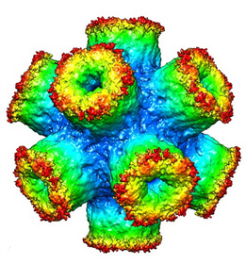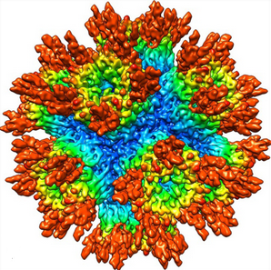

Procedures: Your group will be given a module kit. Each kit should include a magnetized model of proteins, plastic container, and plastic container lid. You will run a test on the “proteins” to figure out how long it takes for them to self-assemble. You will shake the box in intervals of 20 seconds and after each interval count the number of pieces assembled. Make sure to record your data. Make sure everyone in your group has a job. One person will time the intervals and state when to go and stop. One person will shake the container. One person will count the number of pieces assembled after each interval. One person will record the data. You may rotate jobs.

- Make sure lid is securely on the container.
- Shake the container for 20 seconds. Record how many pieces self-assembled.
- Repeat step 2 for a total of 4 minutes.
- Once all of your data is collected, plot the points from the table on the graph. The x-axis will be “time” and the y-axis will be the “number of pieces” self-assembled.

- BEFORE YOU BEGIN: What do you think will happen when you try to self-assemble the “proteins”?

____________________________________________________________________________________________________________________________________________________________________________________________________________________________________________________________________________________________________________________________________________________________________________________________________
Time | Number of Pieces  Self-Assembled | Observations
20 seconds
40 seconds

60 seconds
(1 minute)

1 minute
20 seconds
1 minute
40 seconds
2 minutes
2 minutes
20 seconds
2 minutes
40 seconds
3 minutes

3 minutes
20 seconds
3 minutes
40 seconds
4 minutes

Graph:

- Draw a best-fit line on the graph. Which way does the line go?

__________________________________________________________________________________________________________________________________________________________________________________________________

- Compare your graph to another group’s graph. Do they look similar? What are any differences you see?

____________________________________________________________________________________________________________________________________________________________________________________________________________________________________________________________________________________________________________________________________________________________________________________________________

- Were your proteins assembled correctly? If not, describe what it looked like. What are some issues that may occur when proteins are misassembled?

____________________________________________________________________________________________________________________________________________________________________________________________________________________________________________________________________________________________________________________________________________________________________________________________________

- Does this type of self-assembly normally happen at a large scale, or in everyday life? Why or why not?

____________________________________________________________________________________________________________________________________________________________________________________________________________________________________________________________________________________________________________________________________________________________________________________________________

