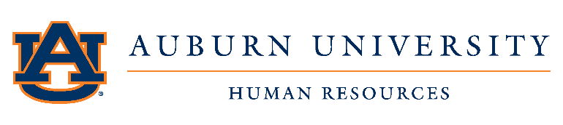
HR Liaisons Network Meeting Agenda
DATE: February 7, 2019 ATTENDING: HR Liaisons and HR Staff
Agenda Item | Speaker
- Welcome & Announcements  - Brittany Saliba – Manager, Records – 2/4/2019  - Onboarding Center visits – GA Tech and NC State  - ID Card Services – waiting on space configuration  - Pre-Employment Process (Pre-AU) – pilot Update (Chris)  - Employee Pictures (Patrick)  - Everify Outstanding Cases | Leanne Fuller
- HRL Updates  - HRL Updates  - College of Business – Julene Pugh – 1/21/2019  - Website – new directory  - Next meeting – currently scheduled March 7, 2019  - International Hiring Process – reminder of FNTF completion  - HRL Resources Advisory Council  - Meeting – February 12  - Topics being finalized | Leanne Fuller
- Office of Sponsored Programs  - Expense Distribution Codes | Martha Taylor
- Policy & Procedures Update & Communication Update  - Hardship Policy & Procedures  - Dependent Education Benefit Policy  - Employee Education Benefit Policy  - E-verify for Federal Contractors Procedures | Tonya Dupree
- Employee Relations  - Employee Appreciation Week | Sonya Dixon
- Records Information  - I-9 dates and paperwork dates – new hires  - EPAF deadlines  - BW EPAFs – deadline is (typically) the Friday before the payroll closes  - MN EPAFs – deadline is one day prior to the running of late pays and LWOs  - SM EPAFs – deadline is one day prior to the running of late pays and LWOs  - CT300 – Intro to Banner HR - 3/20/2019 | Brittany Saliba  April McFarlin
- Compensation/HRD Timeline & Communication  - Job Family Promotions  - Performance Management | Bill Shannon  Shelly Murray  Patrick Johnston
VIII. Q & A | Leanne Fuller

