A Guide to the New Performance Review Form

This is a new, simplified alternative to the traditional Performance Management Planning and Review Form. The new form reflects all of the information that was on the traditional form, but in a simplified and consolidated manner.
NEW! A 5-point rating scale applies to each Job Duty, Responsibility, Position Goal, or Previously Identified Development Need, as well as to the Overall Rating for the performance year.
NEW! The “Universal Performance Dimensions” and “Job-Specific Competencies” sections are absent on the new form. Rather than rate these factors independent of the Job Duty, Responsibility, Position Goal, or Previously Identified Development Need, you are asked to indicate one or two behaviors that have been observed or not observed. These factors contribute to the success or failure of achieving the four stated components.
Please use these guiding tips for the new form. If you have questions, contact Bill Shannon at 844-1602, or email wps0012@auburn.edu.
Job Duties/Responsibilities/ Position Goals/Previously Identified Development Need
Sourced from position/job description, previous performance review, or assigned goal(s) or developmental needs that have been addressed during the current performance period.
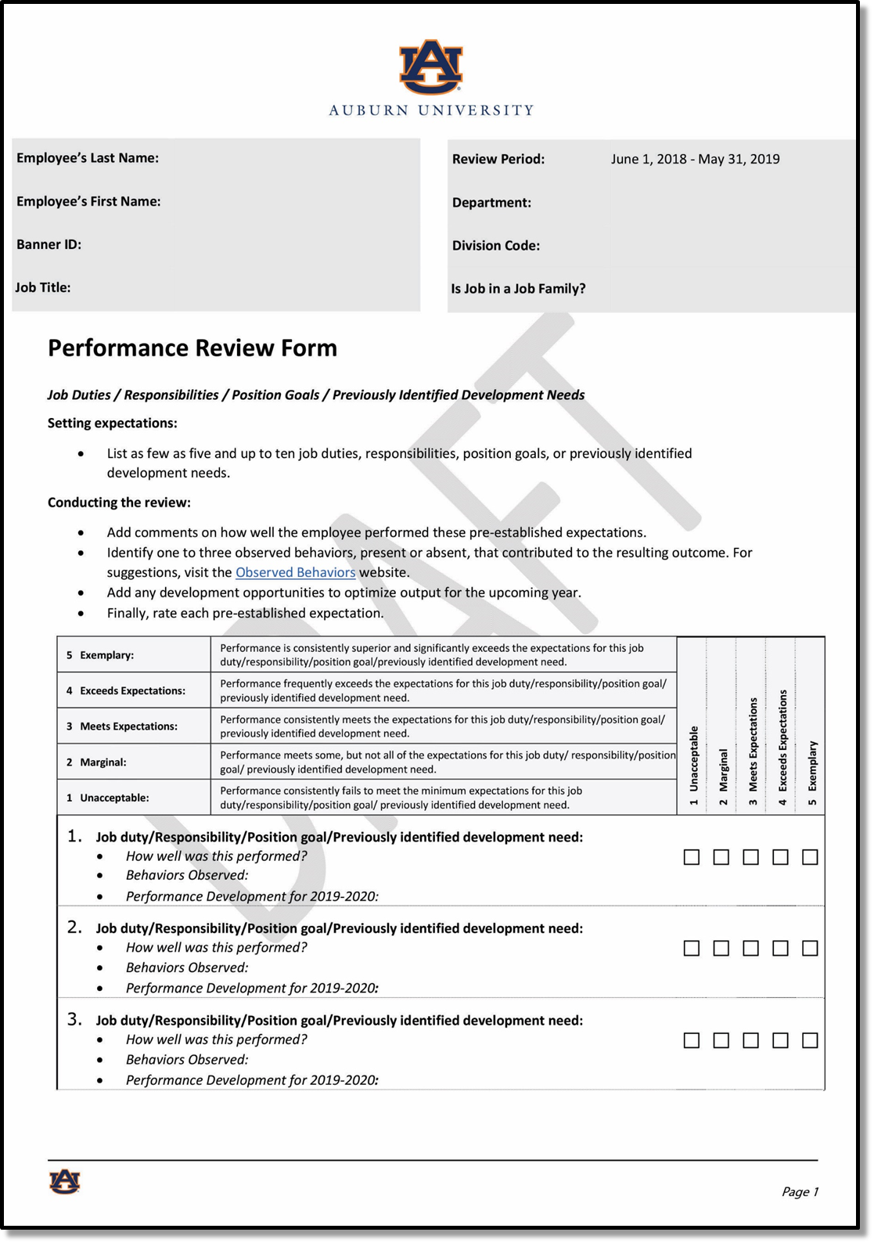

“Observed Behaviors”
(Now integrated with results)

Replaces Universal Performance Dimensions and Job Specific Competencies. Observed behavior definitions and examples by varying performance levels are available to review and/or copy and paste into the form.

New 5-Point Rating Scale
5) “Exemplary”
May Replace “Leading Performance”
Performance is consistently superior and significantly exceeds expectations.
Typically, in a “performance-oriented” culture, 5 to 7 percent of employees will be performing at this overall rating level.

4) “Exceeds Expectations”
May Replace “Leading Performance”
Performance frequently exceeds expectations.
Typically, in a “performance-oriented” culture, 30 to 35 percent of employees will be performing at this overall rating level.
3) “Meets Expectations”
Replaces “Strong Performance”
Performance consistently meets expectations.
IMPORTANT: This is a very good rating.
Typically, in a “performance-oriented” culture, 50 to 60 percent of employees will be performing at this overall rating level.
2) “Marginal”
Replaces “Building Performance”
Performance meets some, but not all of the expectations.
Typically, in a “performance-oriented” culture, 4 to 5 percent of employees will be performing at this overall rating level.
1) “Unacceptable”
Replaces “Improvement Essential”
Performance consistently fails to meet the minimum expectations.
Typically, in a “performance-oriented” culture, roughly 2 percent of employees will be performing at this overall rating level.

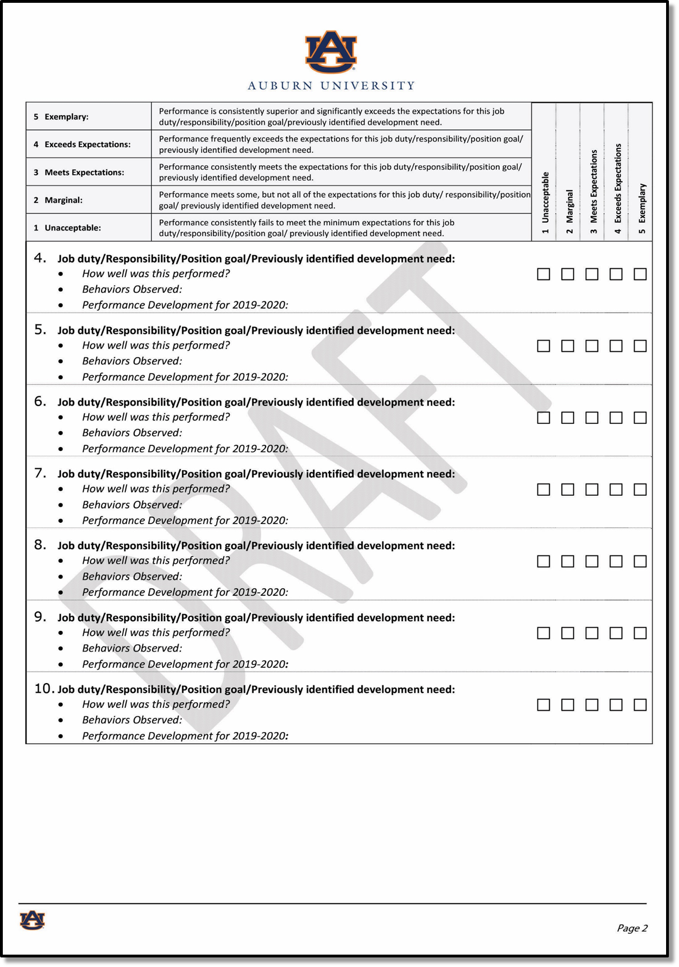

Performance Rating “Check-box”
Supervisor’s Performance Rating for each duty/responsibility/position goal/previously identified development need.

“How well was this performed?”
Supervisor’s assessment and commentary on how well the employee fulfilled this requirement during the Performance Period.

“Behaviors Observed”
Replaces the Universal Performance Dimensions and Job Specific Competencies by integrating what behaviors were observed being demonstrated, or not demonstrated, that contributed to the employee’s resulting performance outcome for this requirement, into the supervisor’s comments. Observed behavior definitions and examples by varying performance levels are available to review and/or copy and paste into the form.

“Performance Development for 2019-2020”
Supervisor’s identification of required areas for improvement or development in the areas of knowledge, skills, and/or behaviors that would directly support or enhance the employee’s future successful performance outcome for this Job Duty, Responsibility, Position Goal, or Previously Identified Development Need.

Job Duty, Responsibility, Position Goal, and Previously Identified Development Need
See Appendix for four examples of the subsections completed for four different jobs. They represent examples of a 1) job duty, 2) responsibility, 3) position goal, and a 4) previously identified development need. Each Duty/etc. is rated using the new 5-point scale. Each of the following requested content is completed:
Job duty/Responsibility/Position goal/Previously identified development need:
How well was this performed?
Behaviors Observed:
Performance Development for 2019-2020:

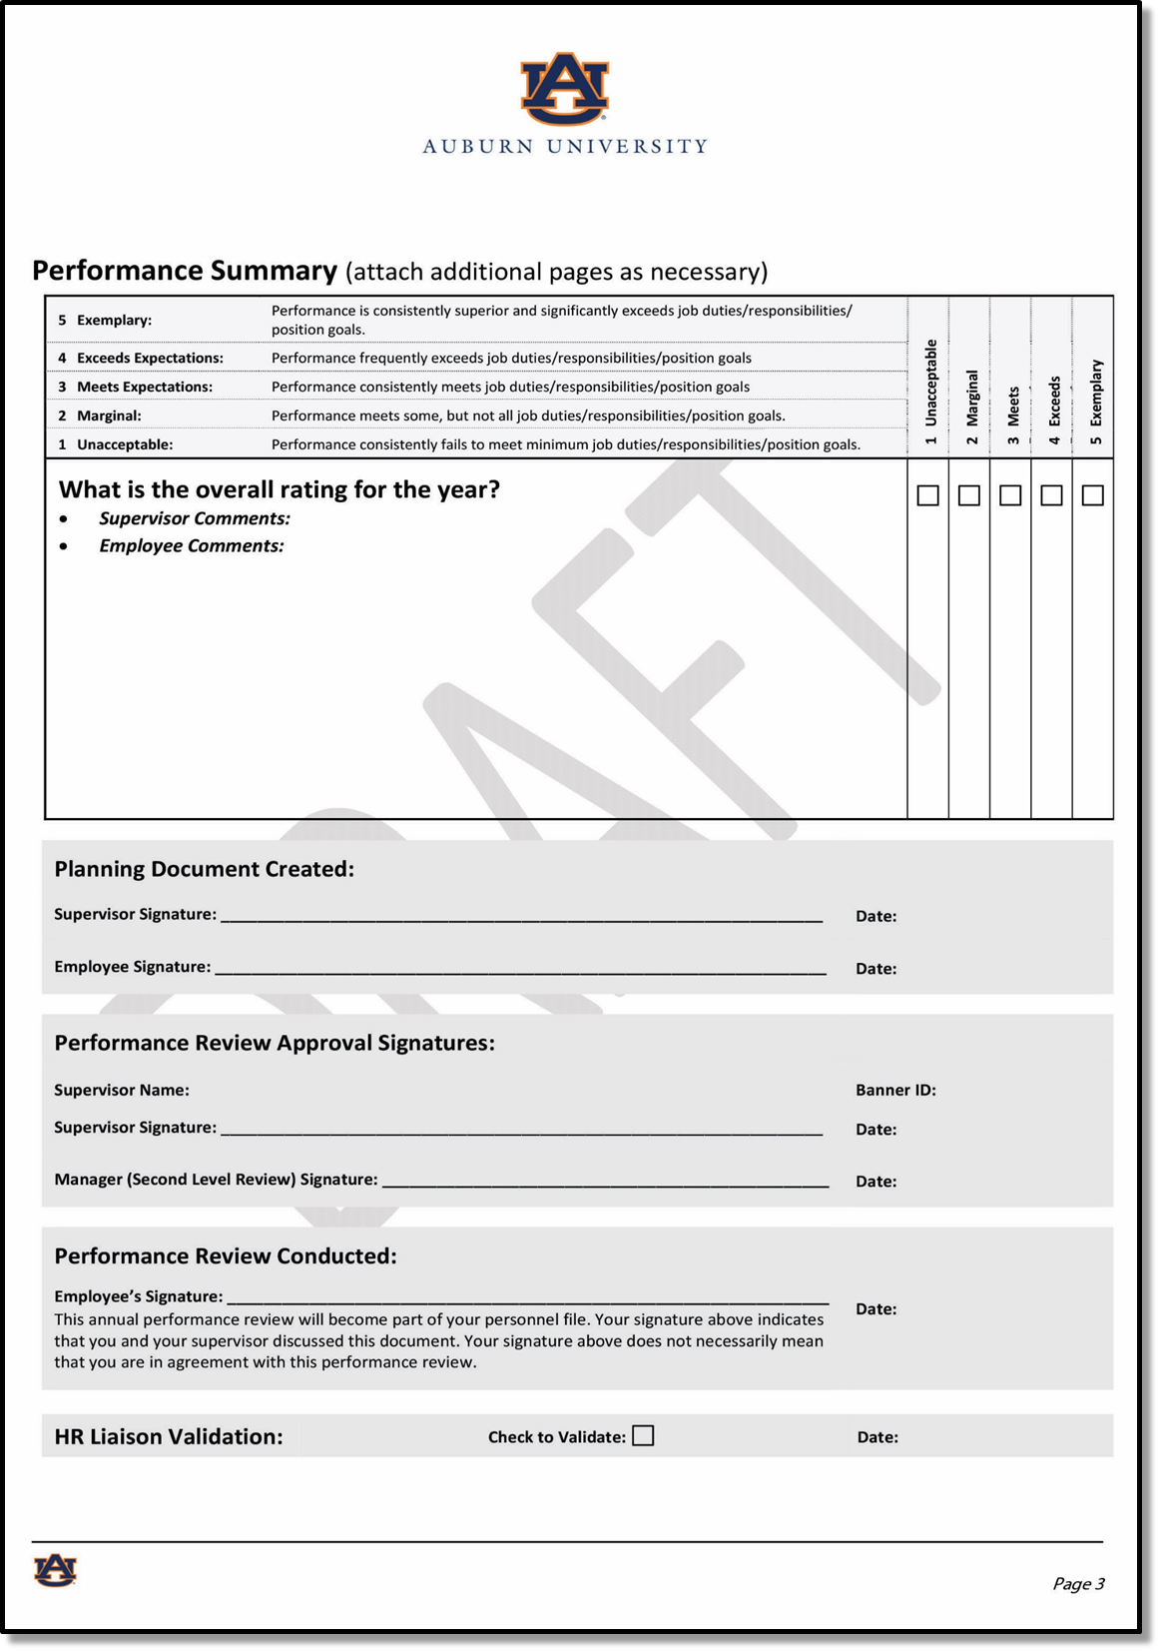

“What is the overall rating for the year?”
Supervisor checks (x) the performance rating that appropriately represents the employees “overall” performance outcomes/results for the Performance Period. Summary comments are added as appropriate.

“Employee Comments”
Employee is encouraged to comment as they see appropriate. However, it is not required for the employee to comment on the review form.

“Supervisor’s Signature” and “Reviewing Supervisor’s Signature”
Prior to the performance discussion with the employee, the supervisor signs the form and submits the form to their supervisor (Manager) for review and signature.

“Employee Signature”
It is not required for the employee to sign the review form. Should the employee refuse to sign, the Supervisor notates that fact on the “Employee’s Signature” line, initialing, and dating the note.

“HR Liaison Validation:”
HR Liaison reviews, validates completeness and accuracy, and checks the “Check to Validate” box with date.

See the Appendix on the next page for examples of completed Job Duty, Responsibility, Position Goal, and Previously Identified Development Need.

APPENDIX

Examples for Job Duty, Responsibility, Position Goal, and Previously Identified Development Need

Example 1: Technician, Print Shop (“3 – Proficient Performance”)


5. Job duty/Responsibility/Position goal/Previously Identified development need: Designs, proofreads, and delivers printed materials for customers on campus on time and without errors.
- How well was this performed? Chris met every deadline, in some cases delivering materials ahead of schedule. No items were returned for errors or quality issues.
- Behaviors Observed: Accountable for Results: Chris demonstrated clear standards for quality results; maintains timeliness and quality.
- Performance Development for 2019-2020: None required for this duty.

Example 2: Administrator, Program (“2 – Inconsistent Performance”)

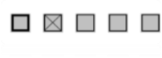
6. Job duty/Responsibility/Position goal/Previously Identified development need: Maintains files and records in compliance with government and University policies, processing and routing all academic forms and student documents, managing databases in various technological platforms.
- How well was this performed? Pat has missed several deadlines and needed assistance from several colleagues to keep accurate documents and databases
- Behaviors Observed: Individual Efficiency: May provide too much or too little information, or does not provide timely, accurate information
- Performance Development for 2019-2020: For this responsibility, Pat must complete two classes in time management in the next three months and show documented improvement in efficiency meeting deadlines and keeping accurate records.

Example 3: Administrator, Contracts (“4 – Highly Proficient”)


5. Job duty/Responsibility/Position goal/Previously Identified development need: For this review year, Taylor needed to improve efficiency in processing subcontract invoices for payment and ensure that correct accounting and contractual elements are consistently in place.
- How well was this performed? As a previously identified development need, Taylor showed dedicated and focused improvement in this area. Taylor took several classes to improve financial and contact software skills, and organized and created materials for three lunchtime learning sessions to share key learnings to members of the department. Taylor not only improved individual efficiency, but colleagues in the department look to Taylor for guidance and coaching.
- Behaviors Observed: Technical/Professional Knowledge: Taylor now has the technical and professional knowledge to do the job at a high level of accomplishment and is knowledgeable in the best practices in the department or function. Taylor is willing and able to learn new skills and knowledge.
- Performance Development for 2019-2020: Given a willingness to improve, Taylor will complete beginning and advanced training in SharePoint and Box by February to report to the leadership team on feasibility of adoption in the department.

Example 4: Coordinator, Grants and Contracts (“5 – Exceptional”)


5. Job duty/Responsibility/Position goal/Previously Identified development need: Lead Grant Monitoring Report project from inception to approval, providing recommended solutions, technologies, and operational efficiencies to ensure quality improvement and labor savings.
- How well was this performed? For this position goal, Mo exceeded every expectation of the deans and departmental leadership. The report’s recommendation saved over $70,000. Time from application to approval decreased 30 percent and is continuing to trend downward as more administrators are trained. All this was done without additional technology investment as Mo created database shortcuts using our current system.
- Behaviors Observed: Planning and Organization: Mo spent necessary time to properly plan and organize this project. He developed strategies to complete work by actively spending time understanding and analyzing group processes, and expertly marshalling resources to get information and staff he needed to complete and exceed the desired outcomes.
- Performance Development for 2019-2020: Mo will attend Project Management Phase 2 in order to achieve the International Project Manager Professional Designation.

