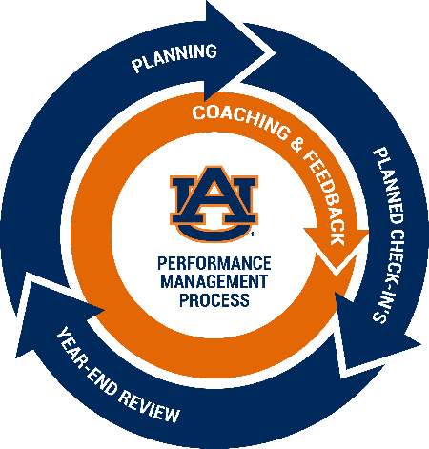

Auburn University Employee Self-Appraisal Form
This form can be used to gather information prior to the Year-end Performance Review. Use of the form is optional.
Name:
Job Title:
Department:
Supervisor Name:
Rating Period:

1. Briefly assess your job performance for the year. Consider how you performed against your Job Duties/Responsibilities/Position Goals or Previously Identified Developmental Needs:
2. List your most important accomplishments for the year:
3. List which Behaviors were demonstrated successfully in your performance. Consider how these Behaviors align with your Job Duties/Responsibilities/Position Goals or Previously Identified Developmental Needs:
4. List any challenges that made it difficult to meet expected Job Duties/ Responsibilities/Position Goals or Previously Identified Developmental Needs:
5. List any special accomplishments, awards, activities, or classes completed during the performance year:
6. List any Position Goals or Developmental Needs you suggest be part of our Planning session for the upcoming year:
7. Please add any additional comments to consider:

I would like a copy of this form attached to the Performance Review Form and placed in my personnel record in Human Resources: Yes No

Signature _______________________ Date: _______________
Please send this form to your supervisor at an agreed date and time prior to your Performance Review meeting.

