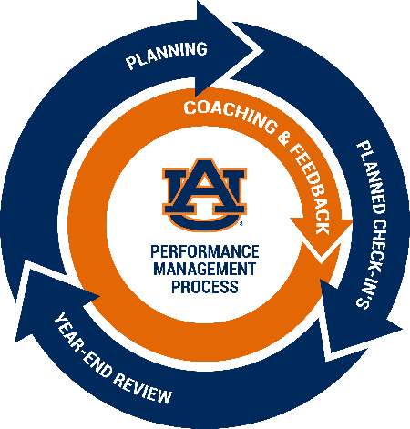

Auburn University Employees Performance Management

Planning for your Planning Discussion

This tool is provided to employees in order to prepare for Planning phase conversations with their supervisor.

Name:
Job Title:
Department:
Supervisor Name:
Performance Year:

- List any job duties you feel should be a significant part of your performance in the upcoming performance year:

- List any responsibilities you feel should be a significant part of your performance in the upcoming year:

- List any specific behaviors (link) you feel should be demonstrated in order to successfully complete your job duties or responsibilities in the upcoming performance year:

- List several goals you would like to achieve in the upcoming performance year:

- List any development goals you would like to accomplish or complete in the upcoming performance year:

- Add any comments you would like to discuss with your supervisor in your Planning meeting:

References:
- QuickDive Videos
- Fast-Train
- Performance Management

