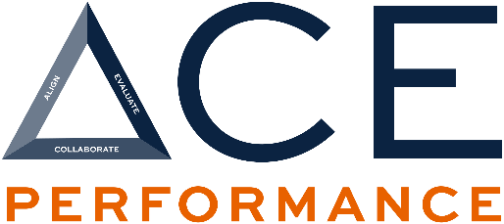

How Supervisors Can Use Job & Position Descriptions in Performance Evaluations
Job and position descriptions are practical tools that help supervisors evaluate performance consistently, fairly, and based on clear expectations. Auburn’s JDXpert system makes these documents easy to access and apply directly within the performance review process.

How To Access the Employee’s Job or Position Description
Supervisors can view job and position descriptions for their A&P and Staff employees through JDXpert, which is available in AU Access under Employee Tools.
Before reviewing employee records, supervisors are encouraged to reference the attached Supervisor Guide, which provides step-by-step instructions for locating job and position descriptions.

Job Descriptions vs. Position Descriptions
Understanding the difference between these two documents is key:
- Job Descriptions:
Outline general duties and minimum requirements for a role at the university level.
- Position Descriptions:
Provide detailed duties and responsibilities specific to an individual employee’s role within their department.
Both documents are useful, but position descriptions are especially valuable when evaluating individual performance

Click here to learn more about the difference between job descriptions and position descriptions at Auburn.

How to Use Position Descriptions in the Performance Review
Supervisors are encouraged to copy and paste job responsibilities directly from the employee’s position description into the performance evaluation form.
After pasting, supervisors can:
- Assess how effectively the employee performed each listed responsibility
- Provide specific examples tied to actual duties
- Identify strengths, accomplishments, and opportunities for development
Using the position description helps keep the evaluation centered on duties the employee is currently performing.

Why Linking Position Descriptions and Performance Matters
Linking position descriptions to performance evaluations benefits both supervisors and employees. It helps:

1. Clarify Expectations:
Performance feedback is grounded in documented responsibilities, reducing confusion and misunderstandings about what success looks like in the role.

2. Support Fair and Consistent Evaluations:
Evaluations are based on defined duties rather than assumptions or informal expectations, promoting consistency across employees and departments.

3. Strengthen Feedback and Development Conversations:
Supervisors can provide more meaningful feedback and identify development opportunities by referencing specific job responsibilities.

Maintaining Accurate Position Descriptions
Position descriptions should be reviewed and updated when needed to reflect:
- Changes in job duties (added or removed)
- The need for increased clarity or reduced ambiguity
- Shifts in departmental goals or structure
Important: It is acceptable for a position description to closely match the job description, particularly when:
- The role aligns closely with the general job description
- The job description is highly specialized or unique
If updates are required, your HR Liaison will provide additional guidance.

Need Help?
For additional information:
- Visit aub.ie/jdxpert
- Email aucomp@auburn.edu
- Contact your HR Liaison

