Final Report to the University Senate  
on an Evaluation of a  
Proposed New University Budget Model

Prepared by:

The Ad Hoc Senate Committee on Strategic Budgeting   
(AHSCSB)

Committee Membership:

Olin Adams – Associate Professor, College of Education  
Michael Baginski – Associate Professor, College of Engineering  
Richard Burt – Professor & Head, School of Building Science  
Drew Clark – Director, Institutional Research & Assessment  
Randall Clark – Professor, School of Pharmacy  
Royrickers Cook – Assistant V.P. University Outreach  
Claire Crutchley – Associate Professor, College of Business  
George Flowers – Dean, Graduate School  
Constance Hendricks – Professor, School of Nursing  
Claudine Jenda – Librarian IV, Library  
Bernhard Kaltenboeck – Professor, College of Veterinary Medicine  
Zhanjiang Liu – Associate V.P. Research & Associate Provost  
Robert Locy – Professor, College of Sciences and Mathematics  
James Prevatt – Extension Specialist Professor, College of Agriculture  
Marcie Smith – Senior Associate V.P. Business & Finance  
Barb Struempler – Professor, College of Human Sciences  
Larry Teeter – Professor, School of Forestry & Wildlife Sciences, Chair  
Joseph Vonasek – Assistant Professor, College of Liberal Arts

March 31, 2015

At a meeting of the Auburn University Senate on June 17, 2014 a resolution was approved to establish an ad hoc committee to review a new university strategic budgeting model and procedures surrounding its implementation. Specifically, the Ad Hoc Senate Committee on Strategic Budgeting was charged to:

…present a report to the University Senate by the end of March, 2015, with an analysis of the proposed budget model as well as of viable alternative budget models, if any, that will focus resources on institutional mission and priorities, along with its recommendations for the strategic budgeting initiative at Auburn University… (full text of the resolution is attached)

The Senate Rules Committee was charged with assembling the committee, including membership from each College and School. Key Administration representatives were invited to serve on the committee who could provide information as well as perspective for the faculty members and included administrators representing research, outreach, the Graduate School and budget development services. The committee as a whole met eight times, beginning in late July, with additional sub-committee meetings called as needed. This report represents the culmination of our review based on what we understand about procedures that will be followed to implement the model in the future.

Acronyms Used in the Report

RCM – Responsibility Center Management

SCH – Student Credit Hour

CSP - Central Support Pool or CSAP – Central Support Allocation Pool

MEF – Mission Enhancement Fund

PLS – Partial Least Squares

OMB – Office of Management and Budget

FTE – Full Time Equivalent

**Background**

The current budget process and model has a long history that spans many decades. Auburn’s current budget is made up of individual budgets for four divisions: the Auburn University main campus (Division 1), Auburn University at Montgomery (AUM – Division 2), Alabama Agricultural Experiment Station (AAES – Division 3) and the Alabama Cooperative Extension System (ACES – Division 4). Division 1 funds primarily consist of revenues from student tuition and state appropriations. Historically (and currently) funds are allocated from these pooled Division 1 funds to the Colleges, Schools, Departments and other operating units based on previous allocations and precedents. A campus culture of adjusting each unit’s budget up or down year-after-year according to increases or decreases in the Division 1 pool has resulted in a situation that provides very little flexibility (according to the Provost’s office) to respond to changes in enrollment trends and new programmatic education opportunities.

The Division 1 pool contains unrestricted and restricted funds. Unrestricted funds are the base and soft funds from tuition and state appropriations and also include professional fees, clinic fees, distance education and study abroad fees that a unit generates. Base funds are generally allocated centrally through the budget process on an historical and incremental basis. Unrestricted soft funds are directly allocated to the generating unit. Restricted funds typically come from gifts, grants, and endowment earnings and always come with restrictions on how they are used. Restricted funds are allocated directly to the benefitting unit.

**Shortcomings of the Current Budget Process and Model**

In the current budget model, funds are controlled centrally. There is a special focus on simply managing and controlling expenses. This activity is often performed by accountants and department managers. Departments and colleges have limited means for allocating resources to new academic initiatives that require an increase in the budget. The committee first charged by the Provost to investigate budget model alternatives found that there are special challenges in the current budgeting process that include:

1. Reduced state support;
2. Increased risk from tuition dependency, which increased 43% from 2008-2013;
3. Increased price sensitivity regarding tuition increases;
4. Increased competition for students and faculty;
5. Changing student population demographics;
6. Increased faculty/staff salary compression;
7. Limited funds for strategic support of growing areas of research, instruction or service;
8. No increased allocations for unit maintenance, operations and professional travel.

**Budget Model Alternatives**

From a review of the literature on trends in higher education and a review of best budgeting practices at peer institutions, four common budget alternatives were noted. See Table 1 for a summary of the key features.

|  |  |  |  |
| --- | --- | --- | --- |
| Common Budget Model Alternatives | | | |
| INCREMENTAL | FORMULA | PERFORMANCE | INCENTIVE-BASED |
| Centrally driven | Unit-based model focused on providing equitable funding | Unit-based model focused on rewarding mission delivery | Focus on academic units |
| Current budget acts as "base" | Unit rates are input-based and commonly agreed upon | Unit rates are output-based and commonly agreed upon | Incorporates a devolution of revenue ownership to local units, as generated |
| Each year's budget increments (decrements) adjust the base | Annual fluctuations are driven primarily by the quantity of production and not from changes to rates | Annual fluctuations are driven primarily by changing production and not from changes to rates | Allocates costs to revenue generating units |
| Focus is typically placed on expenses |  |  | Uses a centrally managed 'subvention pool' to address strategic priorities |
|  |  |  |  |

Table 1. Common Budget Alternatives

From: ‘Strategic budget initiative: provost open forum. November 19, 2013.’  
http://www.auburn.edu/academic/provost/Strategic%20Budget%20Initiative/campusupdates.html

**Findings of the Provost’s Budget Committee**

***Need for a New Budget Model***

A shift in the process for budgeting funds is needed to allow for:

1. Fund allocation that is based on planned priorities and not just history;
2. Long-term planning as opposed to short-term allocations that are simply reactive; and
3. Stake-holders such as departments, colleges, units being empowered to enhanced decision making with the needed authority, responsibility and accountability.

***Guiding Principles***

The following guiding principles were considered important for a new budget model and were developed by the strategic budgeting initiative steering committee after consulting with Huron Education Consulting:

* Prioritize funding of strategic initiatives aligned with Auburn’s mission;
* Deliver consistent, accurate and realistic financial projections, while allowing flexibility to respond to future opportunities and unknowns;
* Promote authority, responsibility, and accountability, both locally and University-wide;
* Provide incentives for effective management of both revenues and expenses and reward creativity and innovation;
* Be simple, transparent, and logical.

**A Brief Review of Responsibility Center Management (RCM) Budgeting and the Currently Proposed RCM Budget Model for Auburn**

The budgeting framework being proposed by Auburn’s administration is very similar to what is generally referred to as Responsibility Center Management. Using this model, Colleges and Schools are identified as responsibility centers capable of generating revenues and incurring costs.

Under the currently proposed RCM model, Auburn University’s “centers” would be grouped at the College level of the organization and each College’s Dean would become a Responsibility Center Manager. The currently proposed model has a structure composed of four separate budgetary units. The units include the following entities:

|  |
| --- |
| * Auburn University Main Campus (AU Main Campus) |
| * Auburn University – Montgomery (AUM) |
| * Alabama Agricultural Experiment Station (AAES) |
| * Alabama Cooperative Extension System (ACES) |

It should be noted that all benefits provided by administrative and support service units to Auburn University Intercollegiate Athletics will be paid for by Athletics. As well, AUM, AAES, and ACES all benefit from the provision of administrative and support services. These operating units would also be allocated the costs of the services they receive.

**Revenues**

Whereas the budget model that is currently implemented does not address certain revenues, the proposed RCM model will employ an “All Funds Approach” in which both restricted and unrestricted revenues will be included. Revenues will be classified as either “Direct Revenues,” which are included in the current model, or “Allocated Revenues,” which are not.

Direct revenues will remain within the college where they are earned and include the following sources:

|  |  |
| --- | --- |
| * Differential tuition and course fees | * Gifts and private support |
| * Graduate distance learning fees | * Investment income |
| * Contracts and grants | * Sales and services |

Allocated revenues will be divided into allocation pools. The sources of these revenues are:

|  |  |
| --- | --- |
| * Gross tuition | * State appropriations |
| * Mandatory fees | * Indirect cost recovery |

The proposed RCM model does not weight Student Credit Hours (SCH), but the model does use an accounting of SCH to allocate tuition revenues to Colleges and Schools. The model assumes that structural differences in the costs of instruction will be offset by direct revenue from any differential tuition that might be charged and/or the support that would be provided through a proposed “Mission Enhancement Fund.” The Mission Enhancement Fund is described in more detail, below.

**Revenue Allocation: Gross Tuition**

The three sources of gross tuition (Undergraduate, Graduate, Professional) will be further divided into four separate allocation pools classifying tuition as being derived from either “Undergraduate” or “Graduate/Professional” students and further as generated from “Resident” or “Non-Resident” tuition. The table below displays the levels of instruction, residency classification, and the proposed allocation to the colleges from each. The 70/30 split is intended to support student services (recruitment, advising, retention) activities in the college of record while providing the college of instruction adequate resources to fund instructional activities.

|  |  |  |
| --- | --- | --- |
| **Level** | **Residency** | **Allocation** |
| Undergraduate | Resident | 70% to College of Instruction |
| 30% to College of Record |
| Non-Resident | 70% to College of Instruction |
| 30% to College of Record |
| Graduate/Professional | Resident | 0% to College of Instruction |
| 100% to College of Record |
| Non-Resident | 0% to College of Instruction |
| 100% to College of Record |

**Revenue Allocation: Student Aid and Waivers**

Under the proposed RCM model, “Gross Tuition” is defined as the total of all tuition that would be collected, if every student paid tuition at the published rate. Total gross tuition is offset by the amount the university decides to spend on student aid and waivers. The respective reduction of gross tuition and the amount of the reduction assigned a college is dependent upon the level of gross tuition allocated to that college. Student aid and undergraduate tuition waivers are considered to be contributive to the common good of the University. The decision to award them is made by central administration. The allocation of the cost of student aid and undergraduate tuition waivers assigned to a college is based upon each college’s share of gross undergraduate tuition. Conversely, graduate tuition waivers are considered to be contributive to the good of the respective college or school where it is awarded. The decision to award them is made by the college or school and the allocation of the cost of graduate tuition waivers is based upon each college or school’s share of the waivers it actually awards.

|  |  |  |
| --- | --- | --- |
| **Expense** | **Consideration** | **Cost Assignment** |
| Student Aid | Decision to award is made centrally by Administration | Share assigned to college/school is based on its share of gross undergraduate tuition. |
| Undergraduate Waivers |
| Graduate Waivers | Decision to award is made by college or school awarding | Share assigned is based on actual waivers awarded by a college/school |

**Revenue Allocation: Division 1 Appropriation**

As a state institution, the University has an obligation to advance the level of preparedness of its residents to advance and improve the state’s economy. To that end, the Division 1 State Appropriations to the University are proposed under the RCM model to be divided 70% to resident instruction and academic support and 30% to sponsored programs support. The allocation of resident instruction and academic support to the colleges is based upon a college’s calculated share of gross resident tuition. The allocation of sponsored programs support to the colleges is based upon a college’s share of total sponsored program direct revenues.

**Revenue Allocation: Indirect Cost Recovery**

Under the currently implemented budget model, indirect costs recovered by units accomplishing work under sponsored programs are only partially allocated back to the unit generating the sponsored revenue. The proposed RCM model will allocate 100% of the sponsored program’s indirect costs recovered back to the recovering unit.

**Expenditures**

As with revenues, the budget model that is currently being used does not address certain expenditures. For example, restricted funds are presently not budgeted at the school/college level. As mentioned above, the proposed RCM model will employ an “All Funds Approach” in which all funds will be budgeted and included in the University’s overall budget. Within the individual (College/School) budgets, both direct and indirect expenses will be included. Expenditures will be classified as either “Direct Expenses,” which are included in the current model, or “Allocated Expenses,” which are not.

Direct expenses include the following examples:

* Salaries, wages, and benefits
* Equipment and supplies
* Repairs and maintenance
* Travel
* Other expenses

The proposed RCM model will *allocate* the indirect expense of administration and the costs of support services. These costs will be pooled and allocated to the colleges. The administrative and central support units will not allocate their costs to one another in the process. Exemptions from this assessment of indirect and support service costs will not be permitted. Allocated expenditures will include the following:

* Allocated central unit expenses
* Return to net assets
* Mission Enhancement Fund

Six cost pools (Central Support Pools – CSPs) will be created, with each pool grouping the expense of related central support units. The pools will then be allocated to the colleges, schools, divisions, and auxiliaries using an allocation base for the services represented in the pool. The proposed cost pools and their respective allocation bases are:

|  |  |
| --- | --- |
| **Central Support Pool** | **Allocation Base** |
| Academic and student services  *Examples: Libraries, Student Affairs* | Credit hours taught |
| Administration  *Ex: President’s Office, EVPs Office* | Total direct expenses |
| Alumni affairs and development | Student headcount |
| Facilities  *Ex: Maintenance, depreciation* | Adjusted square footage |
| Sponsored program support  *Ex: VP for Res.& Econ. Devel, C&G Acctg.* | Research expenditures |
| University-wide support  *Ex:OIT, HR, Public Safety* | Total FTEs, Divisions 1, 3, & 4  *(employees + student workers)* |

**Mission Enhancement Fund**

A central objective of RCM is for the operating units to account for the full costs of their operation, where “full cost” represents the total of all direct and indirect costs. What must be addressed by the RCM model is that, in part because of their specific mission objectives and their inherent operating costs, some colleges and schools will be unable to generate their full cost from the total of their direct and allocated revenues. That is, a college or school’s total revenues may be less than the full cost of its programs, resulting in a negative margin. In order for all colleges to have adequate resources to achieve their objectives, the proposed RCM model creates a “Mission Enhancement Fund” (MEF). The MEF is a central pool of funding that is available to provide resources to alleviate any negative margins produced under the RCM model, allowing the University to accomplish its strategic priorities or to invest in initiatives.

The Mission Enhancement Fund is created by applying a participation rate to eligible budgeted revenues of the schools and colleges. While the participation rate itself would remain constant between periodic formal reviews of the budget models, the size of the Mission Enhancement Fund itself would vary from year to year, based on anticipated revenues. The basic intent of the MEF is to contain the amount determined as necessary to provide those colleges and schools with negative margins adequate support to begin their fiscal year at a break-even funding level, plus any identified resources required for strategic investments (new programs or program enhancements that would advance the University’s strategic mission). Thus, the amount can vary from year-to-year, growing or shrinking, dependent upon the amount required.

All colleges and schools, including those that will benefit by receiving funding from the MEF to reach break-even, are required to contribute to the fund. The amount of contribution is established by a “participation rate” applied to certain revenues of each college/school. Not all revenues are considered in the development of the contribution rate. Those that are included/excluded are shown in the table, below:

|  |  |
| --- | --- |
| **Included Revenues** | **Excluded Revenues** |
| Gross tuition and fees | Sponsored program revenues |
| (less) Student aid and waivers | Indirect cost recovery |
| Appropriations | Gifts, private support, and investment income |
| Sales and services |  |
| Other revenues |  |

An example provided to the current committee used FY2012 data and a MEF participation rate of 17.5%. At that level, the MEF was large enough to cover all negative margins as well as provide sufficient resources to fund strategic investments.

**Planned Budget Model Oversight**

As presently proposed, three new University Committees would be formed to provide oversight and guidance for Budget development and implementation along with several existing committees that would monitor the effects of the implementing the new model on curricula.  These include: 

**Proposed Committees**

**Strategic Budget Advisory Committee:** Advises senior leadership on use of the Mission Enhancement Fund; reviews Central Unit budgets that could not be agreed upon by the Central Unit Allocations Committee; submits the final recommended budget to the President; at five-year intervals, proposes a task force to conduct a thorough review of the Strategic Budget Model, including all allocation methodologies and the selected participation rate.

**Central Unit Allocations Committee:** Provides oversight of Central Unit costs by evaluating each unit's cost of operations and level of service on a rotating basis; recommends a comprehensive budget for central units to the Strategic Budget Advisory Committee for final review and inclusion in the University-wide budget submitted to the President.

**Space Management and Deferred Maintenance Committee:** Oversees the deferred maintenance fund and the allocations of its resources to support improvements across the University; prioritizes the list of deferred maintenance items for periodic and as-needed improvements; serves as a broker for units wishing to give up or acquire space.

**Existing University Senate Committees**

**Core Curriculum and General Education Committee, Curriculum Committee, Graduate Council:** In discharging their assigned responsibilities under a new resource allocation model, these Committees will need to serve as a hedge against attempts to game the system by creating courses strictly for financial gain. In addition, these Committees should be encouraged to promote interdisciplinary curriculum development, where appropriate, for the benefit of the University as a whole.

**Ad Hoc Senate Committee’s Evaluation of the Currently Proposed RCM Budget Model**

There are a number of issues/concerns that have evolved from the subcommittee’s review of the proposed RCM model. Some questions are more related to implementation and oversight of the new approach to budgeting proposed for Auburn, while others are more related to the model’s structure. A short list of some of those concerns follows:

1. There is concern that the model could produce swings in the annual resources available for a college or school’s operational expenditures that would make it difficult for them to plan. For this reason there is interest in establishing some maximum year-to-year variation, in terms of a percent of total revenue.
2. There is concern about the magnitude of the shortfalls associated with higher cost programs under the approach to tuition (and other allocated revenues) allocation being recommended. The goal of many RCM models is to incentivize managers to become more efficient and to generate revenues in excess of their costs, which they can then carryover to future years for special projects. Under the currently proposed allocation method, it is unlikely that many colleges will reach the breakeven level without MEF funding.
3. How will the historical distributions of funds by deans within the colleges compare to the proposed RCM model distributions? Will there be comparable incentives in place for departments and will they be rewarded for increased efficiency?
4. More detail is needed about procedures for monitoring the effectiveness of any new modeling framework that is ultimately adopted. Fixed cost charges and bases for those charges will require regular oversight.

As a committee response to addressing some of these concerns, several sub-committees were charged with examining specific questions including the method of allocating tuition and fees, the specification of allocation bases for cost pools, and implementation oversight.

**Tuition/Fees Allocation and Basic Modeling Suggestions**

Of the numbered concerns mentioned above, 1) and 2) were discussed most frequently in committee meetings. Number 1 relates to concern about the subjectivity associated with evaluating a unit’s performance that generates a negative margin. Under the current proposal, a MEF will be generated through the participation rate that can bring negative margins back to zero such that all unit costs can be met. According to the Provost, following a shadow year where parallel accounting systems will allow the deans to learn how they would actually fare under the new system, actual implementation of the system will take place. For the first year, all units that indicate a negative margin through the budgeting process will be given sufficient resources from the MEF to meet their budget. In subsequent years, that may not be the case. The Provost (whoever that may be at the time) may choose to encourage additional efficiencies by withholding a portion of the funding needed to offset an otherwise negative budgeted margin. For colleges that are anticipated to forecast negative margins into the foreseeable future due to their high costs, this situation is very disconcerting. A guaranteed maximum reduction in revenue contributions of something on the order of 5% from one year to the next would alleviate much of that anxiety.

Concern number 2) relates to the fact that under currently proposed allocation procedures, high cost programs will likely never get to breakeven without help from the MEF and, as a result, seldom (if ever) be in a position to build reserves with carryover funds. This Committee’s discussion centered upon finding a way to allocate Division 1 resources to Colleges and Schools so that fewer units were left with large negative margins and so that the sum of the negative margins was less. This led to the examination of two different approaches to allocating resources to units from the Division 1 pool.

The first of these approaches proposed acknowledging that there are differences in the cost of instruction per student credit hour across the 65 departments on campus. Several other schools implementing RCM have recognized these differences through the application of weights. According to the [National Study of Instructional Costs and Productivity (Delaware Cost Study)](http://www.udel.edu/IR/cost/index.html), national norm costs per student credit hour (by department) range from $158 to $618 per SCH in those disciplines in which Auburn University has instructional programs. Since the price of tuition per SCH lies somewhere between these extremes, the proposed model will allocate to more tuition dollars to some units than they require and other departments will receive less than they need. A system of weights was generated for Auburn University using the cost survey (Delaware) data at the department level and normalizing each value to the mean. Using AU information detailing SCH taught by department, weighted SCH were determined for each department and then summed to the College/School level to determine each unit’s (College/School) share of Gross Tuition. Weights used for AU departments can be found in the Appendix (1).

Two assumptions were made with this approach that were different from the proposal put forward by the administration. First, no distinction was made between in-state and out-of-state students. The supporting rationale for this modification was that it costs the same to teach a student from Alabama, Georgia, Florida, etc., and that it is an inefficient use of department/College funds to recruit for students in multiple states. The University’s brand is primarily responsible for attracting out-of-state students. The second change in assumptions is that all gross tuition goes to the college or school of instruction. This assumption simply acknowledges the fact that there are no good (or similar national norms) data on the separable costs of maintaining/advising students in a department/college. Other distributions of revenues and costs remained the same.

Given these adjustments and data for FY2012, $366,858,679 in gross tuition and fees was available to reallocate to Colleges and Schools. Distribution of the tuition and fees according to the two methods is indicated below:

Original Allocation



Weighted Allocation



Using this redistribution of tuition resources (and leaving other cost and revenue amounts as they were calculated for the un-weighted case), the sum of the negative margins presented in the budget models as ‘Margin Before Mission Enhancement Fund’ is reduced from -$33,188,286 to -$13,461,841 (nearly 60%), representing a reduction in what would be required of a MEF participation rate that could meet the goals of being able to make each unit’s budget balanced while still establishing the fund for strategic investments. Similarly, the FY2013 sum of negative margins before MEF was reduced from -$24,861,070 to -$9,369,154. Figures displaying these reductions in variability are included in the Appendix (2).

*The second approach* evaluated for reallocating base funds in the budget used an even more objective (than national norms on cost per student credit hour) method. Partial Least Squares (PLS) regression was used to estimate the true weights necessary to balance the budget when Tuition+Fees is the resource available to reallocate. The approach considers that:

(Tuition&Fees + (Margin Before MEF)) allocated to Colleges and Schools) / Tuition&Fees = the factor by which to multiply Tuition&Fees to reduce the need for an MEF to balance budgets (an MEF could still be generated for strategic investments). Given the same FY2012 data referenced above, True Weighted Tuition could be estimated and ‘True Weights’ determined:

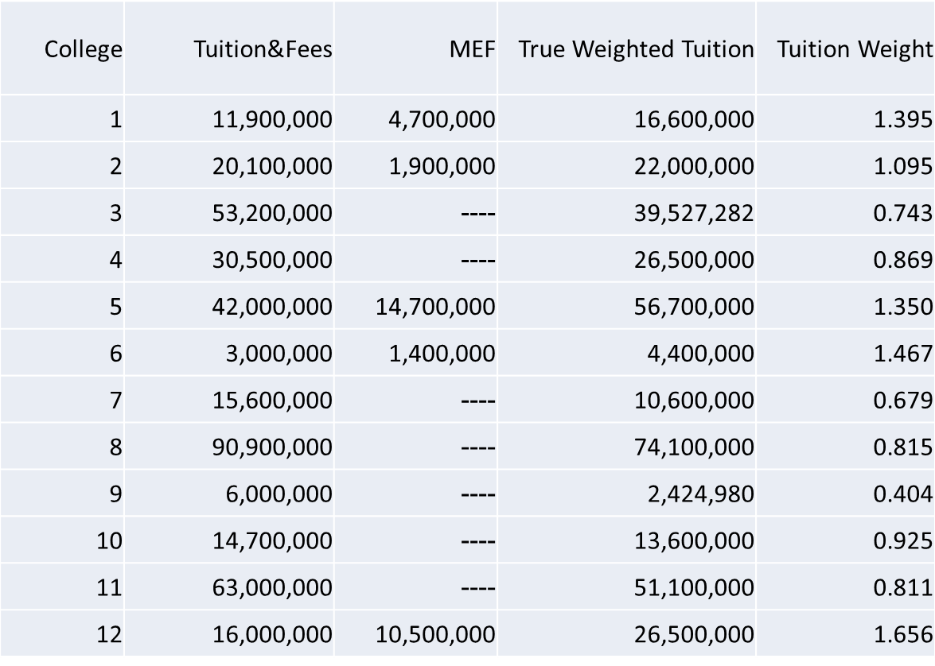  
Note: Margin Before MEF is a measure reported by the model that indicates how close (positive or negative) a unit is to meeting its budget (revenues minus costs) before the MEF participation rate is applied as an additional cost.

**Margin Before  
 MEF**

Using the PLS technique, 22 variables that characterize higher education (number of students, number of faculty, sq. ft. of classroom, etc.) were examined to determine whether they would be helpful in determining the weights. The algorithm ranks the predictive power of the individual variables and discards less useful ones until a minimum set of variables still optimally predicts the outcome (tuition weights developed above). From those 22, the variables selected include the following:

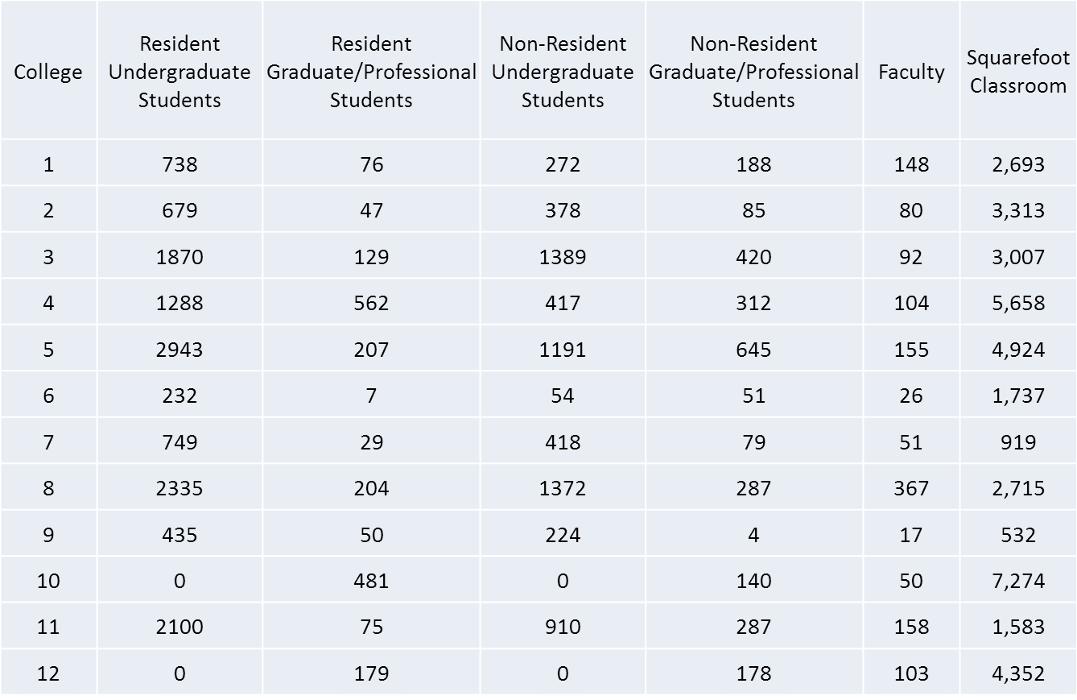

The PLS Model combines these variables with different weights into new variables (termed components) and predicts tuition weight with these components.

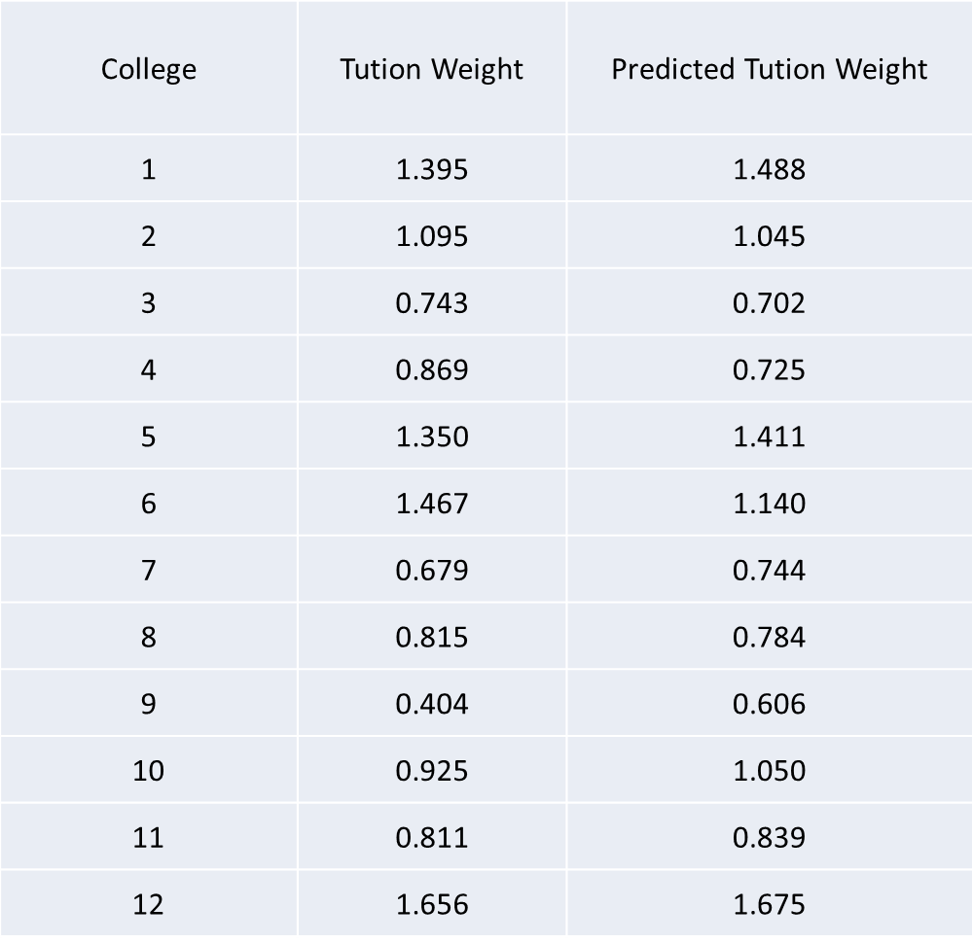

These weights were then used to reallocate Tuition & Fees for FY2012. The following graph indicates the reductions in variation (range) associated with the margins before MEF relative to the unweighted (administration proposed) case.

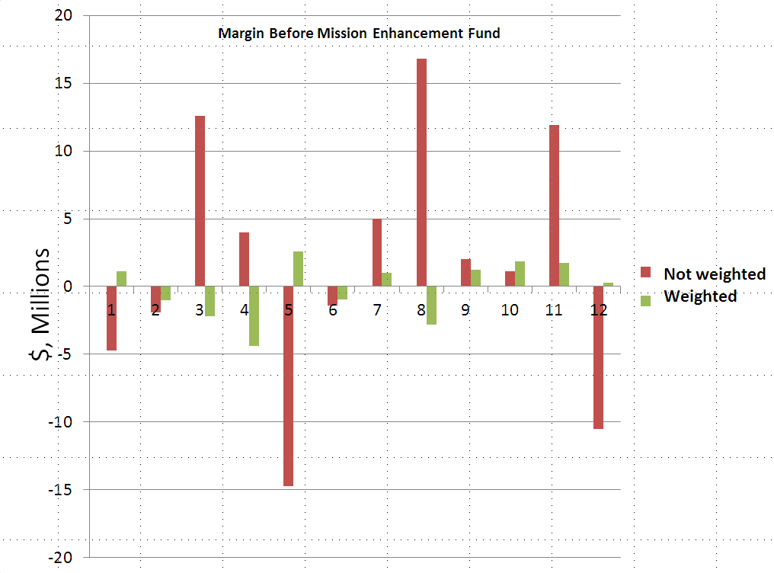

**Central Support Allocation Pools**

Of the issues perceived as being of concern in the Responsibility Center Model (RCM) being proposed, one concept of importance is that of the Central Support Allocation Pool (CSAP) structure used to allocate indirect costs of administration to the colleges and schools within the University. One of the proposed guiding principles of the RCM process is that the process be “simple, transparent, and logical.” This is taken to mean that there is no direct intent to require any of the University’s Colleges to carry a disproportionate burden of the costs of Central Support functions beyond their actual use of such services. In that respect, it is not clear that the proposed CSAP structure is achieving its objective to be “logical.” To be successfully implemented, the University’s RCM will need to have the full faith and commitment of College’s Deans. That commitment will be assured only through fair and equitable treatment.

The standard model for equitable indirect cost allocation of an educational institution’s administrative costs has long been OMB Circular A-21: Cost Principles for Educational Institutions. OMB Circular A-21 was recently replaced by the OMB’s Uniform Guidance as a combined policy document for a number of OMB circulars applying to different institutional types. As it relates to the principles and practices for the allocation of “Facilities and Administration Costs” for institutions of higher education, the changes have been nominal. A key aspect of indirect cost allocation is the distribution to operating units of what can be rationally determined as their representative fair share of the “overhead” costs of an organization. In Circular A-21’s presentation of “Purpose,” it directly states that “(t)he principles are designed to provide that the Federal Government bear its fair share of total costs, determined in accordance with generally accepted accounting principles, except where restricted or prohibited by law.” If, in the preceding quote, one were to substitute the phrase “a College” for ”the Federal Government” this would appear equivalent to the intent of the proposed RCM being addressed by the Committee in this case.

Available at http://www.whitehouse.gov/omb/circulars_a021_2004, Circular A-21 directly addresses the allocation of the costs of Administration, through its treatment of “Facilities and Administration Costs” (F&A costs). Section E 2 (b), specifically addresses its objective to distribute F&A costs to major organizational functions (such as the University’s Colleges) “in proportions reasonably consistent with the nature and extent of their use of the institution's resources” and that it may be necessary to accomplish this through the creation of “cost groupings.” Such cost groupings being “a pool of those items of expense that are considered to be of like nature in terms of their relative contribution to (or degree of remoteness from) the particular cost objectives to which distribution is appropriate.” More specifically, Section F 5 categorizes the “central offices of the institution” and provides examples that include the President’s Office and other central services. In sum, Circular A-21 posits its objective that administrative expense be generally allocated “in proportions reasonably consistent with the nature and extent of their use of the institution's resources” (Section E. 2 (b)). Further, administrative expense “shall be grouped first according to the common major functions of the institution to which they render services” (Section E. 5 (b)) and the costs for the separate categories of administrative cost be aggregated and a separate cost rate be generated for each function (Section G. 2).

By way of example, under the proposed RCM model cost allocation for administrative services required, “Total Direct Expense” may not be generally representative of “the nature and extent of their use of the institution's resources.” A common measure of service requirements used as an allocation base for administration in OMB Circular cost allocation exercises is “number of personnel” or “number of FTE’s.” This is due to the fundamental nature of “administration” being the overall direction of an organization comprised of people. In contrast, “Total Direct Expense” can encompass funding that reflects no personnel. Vis-à-vis accounting services, a common allocation base in such exercises is “number of transactions” (e.g. – a “department” created to provide safety inspection services of university facilities with 10 employees providing inspection services year-round, having operating expenses of $1 million annually, may generate thousands of transactions yearly. Conversely, a department established to pay liability insurance for campus transportation services may have $1 million premiums that are paid biannually and generate a total of 3 transactions – 1 to fund the department and 2 for premium payments).

More generally, using a single allocation base for each of the 6 CSAP’s may produce an easily administered cost allocation system. However, it increases the probability of overloading indirect costs on some colleges or schools while under-loading others. This may well produce substantial dissatisfaction with the process and induce organizational morale issues that could jeopardize the successful implementation of the RCM.

*Concerns Regarding Model Implementation*

A concern of the current committee is that the new budget model, although more decentralized than in the past, does not provide for transparency at the lowest levels (departments) where incentivizing faculty is most important (see 3 above). The committee suggests that some sort of budget monitoring processes be incorporated at the department levels that dovetail with procedures at the College/School level to insure faculty buy-in of the new procedures. There is a fear that we will create a system with great (and needed) transparency above the colleges/deans, yet miss the opportunity to extend the transparency down to and through individual units, possibly leading to both inter-college and intra-college disputes over the budget process that certainly have the potential to be highly contentious.

Regarding the new responsibilities of the existing Senate committees mentioned above, it is unclear that our existing policies/procedures/rules contemplated the decentralization of power that the decentralization of the budgeting process will surely entail. Traditionally, our focus has been on protection of faculty self-governance and academic freedom against assault from the “top down”, but it appears that there are many issues that will result from decentralization that will result not from top-down challenges but from what might be termed more lateral challenges, e.g. fairness of treatment across programs. When you look at some existing procedures, e.g. Academic Program Review and how it fits with reaccreditation and program enhancement/reduction, we may find that what we have now is inadequate to meet potential demands placed on it by our new budgeting process.  In this arena we have always thought in terms of financial exigency leading to program reduction, but in the new budget model it will become possible to either intentionally or unintentionally budget a program out of existence without any program review that considers the relationship of the program to the central mission of the University. Review of compatibility of existing academic policy with the new budget model needs to be conducted in concert with budget implementation.

**OVERALL** **AHSCSB COMMITTEE RECOMMENDATIONS**

The Ad Hoc Senate Committee on Strategic Budgeting has completed a long and thorough review of the rationale and proposed procedures for modifying the way budgeting is done on Auburn University’s Main campus. The members of the committee are in general agreement with the need to develop an approach to budgeting that is both responsive to changes in the economic environment facing the University (and higher education in general) while allowing it the flexibility to invest in new, possibly yet unknown, initiatives. The RCM model and the version proposed here have the potential to provide the change needed for Auburn to move forward. However, as a committee that has reviewed both positives and negatives associated with RCM implementations across the country (approximately 21% of doctoral granting institutions use some form of RCM) we have developed some recommendations:

1. **Tuition and fees should be allocated according to some form of weighting procedure**. The wide variations in ‘Margins before MEF’ are not conducive to incentivizing deans and faculty. Two investigations of weighting methods both gave more units a better opportunity to produce a breakeven budget. Cost of instruction weighting is the most common approach used by other schools (if they choose to use weights at all), but the PLS estimation approach presented here provides the best opportunity to arrive at a set of weights that will get all 12 Schools and Colleges as close to breakeven as possible, while minimizing the value judgements that seem to be associated with weighting instructional costs by discipline (under the PLS approach the weighting criteria are more objective student counts, faculty numbers, square footage of classroom space, etc.).
2. **Re-examine the rationale for splitting tuition into various components (resident/non-resident; department of instruction/department of major).** If a weighting method is adopted as described above, these splits unnecessarily complicate the allocation of tuition and fees to units that need them to balance their budgets.
3. **Year**-**to-year reductions in funding should be capped at 3% of total revenues.** Many of the academic units will face a negative margin as they are forecasting their revenues and costs (in the 2012 example, 2 units faced a shortfall of over $10,000,000). If the MEF contribution to the unit makes it solvent there is no problem. But if in budget negotiations, a Provost suggests awarding less than that amount, that reduction should not exceed 3% of the units total budgeted revenues for the year.
4. **Review the selection of bases for determining contributions to the Central Support Allocation pools**.

1. **Institute a policy that encourages Colleges/Schools to prepare guidelines providing for the participation of departments (and their faculty) in the budget process.**

**Appendix 1.**

**Appendix 2. Model Results Comparing Tuition and Fees Weighted Using Delaware Cost Study Weights vs. No Weights (FY2011 weights for FY2012 and FY2013 budgets)