Poultry Science, Food Science, PhD, 2017

The Poultry Science graduate program includes the traditional poultry science doctoral program as well as an option in food science. These doctoral degrees are designed to prepare outstanding and highly motivated students for careers in the poultry and food industries, government, and academia. During the 2016-17 academic year, 5 students were enrolled in the doctoral programs in the Poultry Science Department (3 food science and 2 poultry science). This report combines the two doctoral level programs associated with the Poultry Science Department.

Student Learning Outcomes

Specificity of Outcomes

SLO 1: Communication - Students will effectively communicate research findings to a broad audience in written or oral formats.

SLO 2: Knowledge - Students will demonstrate poultry or food science knowledge commensurate with the doctoral level.

SLO 3: Research - Students will demonstrate an understanding of the scientific process, solve poultry or food science-related problems, conduct a literature review on a poultry or food-related topic, independently conduct scientific experiments that address questions in poultry or food science, demonstrate an understanding of experimental design, and statistically analyze and interpret data as well as draw valid conclusions.

SLO 4: Teaching – Students will effectively prepare and deliver lecture and/or laboratory material to undergraduate students (new – effective June 2017).

Comprehensive Outcomes

For our doctoral level degree, the above outcomes are comprehensive. Departmental faculty members expect graduates of the doctoral program to be comparably prepared upon graduation as doctoral level students from other Land Grant universities. Our doctoral students should communicate effectively because written and oral communication skills are expected by the industry and academia. Students should have knowledge commensurate with their field of study; because fields vary dramatically from poultry health to poultry nutrition to food safety to food chemistry, SLO 2 was left intentionally broad. The purpose of the doctoral preliminary exam, used to evaluate SLO 2, is to determine if the student has the knowledge base to continue in the doctoral program. With the doctoral program being heavily research-based, students must demonstrate research capability as outlined in SLO 3. Because doctoral students may seek careers in academia, they should also have experience preparing and delivering lecture material (SLO 4).

Communicating Student Learning Outcomes

The outcomes listed above have been distributed to faculty via email and discussed at faculty meetings. The SLO list is also being added to the departmental website so students will be informed of the expectations associated with the doctoral degree program.

Curriculum Map

Curriculum Map

The Department of Poultry Science, recognizing the differences between graduate student programs and research emphases, uses graduate seminar (POUL 7950/FDSC 7950) and the research project (POUL 8990/FDSC 8990) as the major places where the SLO’s are addressed. All students are required to complete graduate seminar and a research project, which is subject to a final examination.

SLO | POUL 7950/FDSC 7950 | POUL 8990/FDSC 8990
1. Communication | 2 | 2*
2. Knowledge | 1 | 2**
3. Research | 0 | 2*
4. Teaching | *** | ***
0 = no coverage; 1 = some coverage; 2 = extensive coverage
*A final defense rubric is used to assess these during the last semester.
**The preliminary exam covering knowledge within the field must be passed to officially become a doctoral candidate.
***The teaching SLO is not associated with a specific course, but is part of the student’s job description as a teaching assistant.

Measurement

Outcome-Measure Alignment

Graduate seminar has had a grading rubric in place for several years to assess oral communication skills (see #7 below). This rubric includes the written abstract and aspects of the oral presentation, which is used to assess SLO 1.

The departmental faculty developed a final defense rubric to assess oral and written communication skills (SLO 1) and knowledge of the research process (SLO 3). Details are again provided in #7 below.

An individualized qualifying examination is used to determine if the student has knowledge commensurate with the doctoral level (SLO 2).

A rubric that evaluates graduate teaching assistants is completed annually, as required by the Auburn University Graduate School. This evaluation form will be used to assess SLO 4.

Direct Measures

All assessment methods directly measure students’ abilities to meet the SLO’s.

Data Collection

Communication skills are assessed initially during graduate seminar, which is held weekly during the fall and spring semesters. Faculty, staff, and students complete a seminar evaluation form (i.e., a rubric), which is submitted to the seminar instructor. Results are reviewed with the doctoral student after the seminar to hopefully improve their future performance. Scores (from faculty only) are reported to the assessment coordinator at the end of the semester. The survey instrument is shown below as Item 1.

To give an overall assessment about a doctoral student’s abilities, a final defense rubric is used by the student’s dissertation committee. This committee consists of 5 faculty members. The final defense is held during the graduate student’s last semester. The rubric contains questions about communication and research ability. Surveys are submitted to the assessment coordinator at the conclusion of the defense.
Item 2 shows the final examination rubric used during the defense.

Teaching ability is assessed using the evaluation form shown as Item 3. The form is completed jointly by the student and instructor of record for the course. It is then reviewed with the student prior to submitting to the Graduate School. This particular SLO is being added effective June 2017.

Item 1. Evaluation tool for POUL 7950/FDSC 7950 used to assess communication skills.

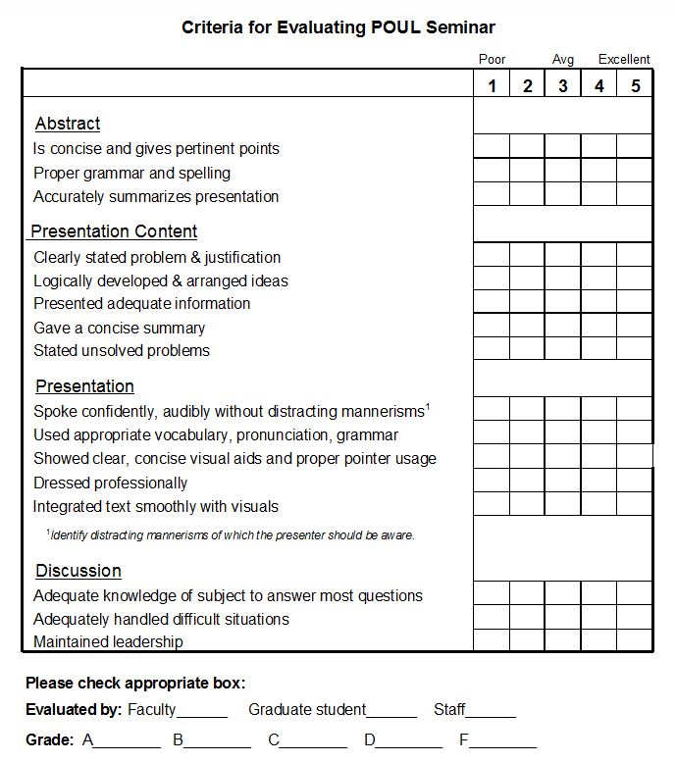

Item 2. Evaluation tool for doctoral final defense.

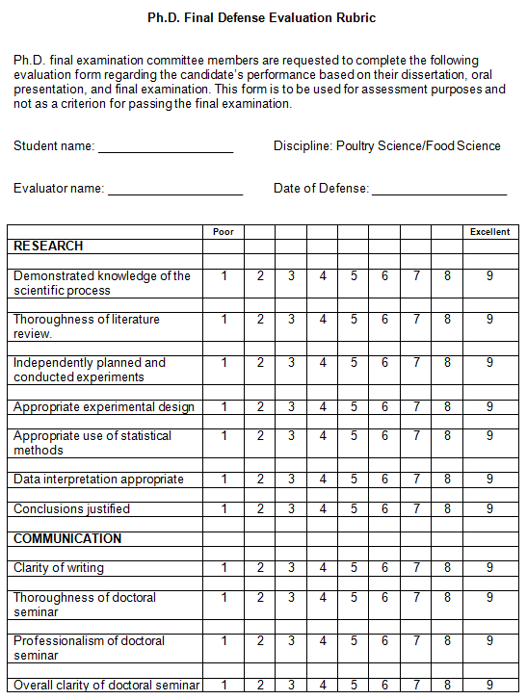

Item 3. Evaluation tool for teaching effectiveness of doctoral student.

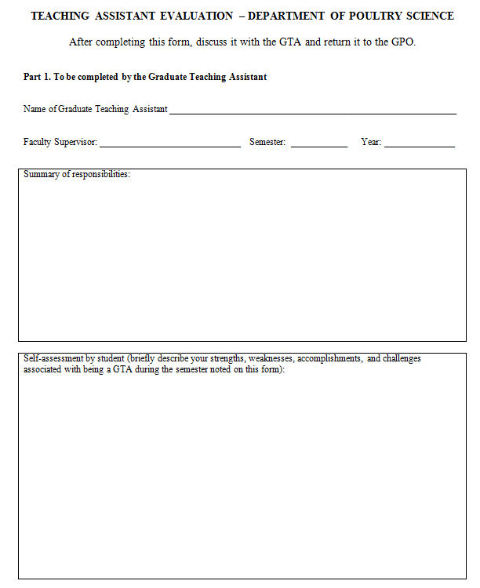
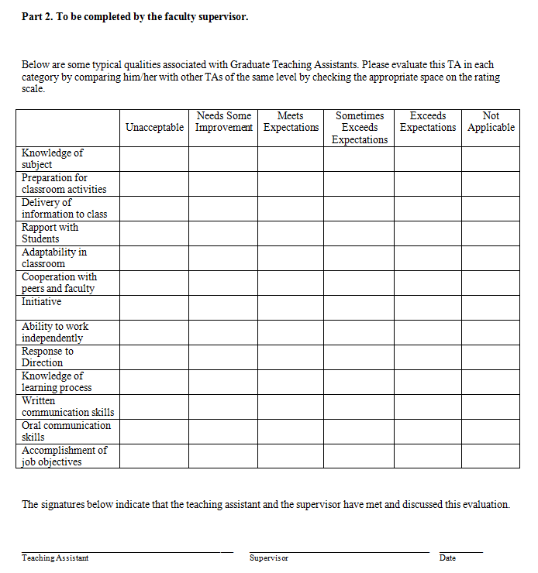

Results

Reporting Results

  - For the evaluation of communication skills by doctoral students, the seminar survey was used. The table below summarizes data from 2013-14 through 2016-17. The number of students is listed parenthetically in the table. Scores are the averages from faculty only.

Table 1. Seminar rubric scores.

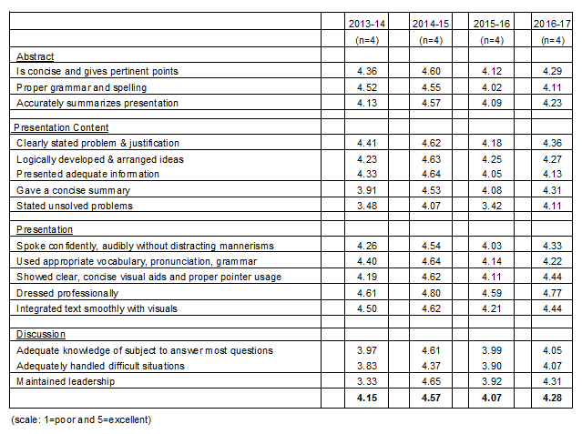

  - The table below summarizes data over the past three years from the doctoral final defense evaluation form. The scale goes from 1 (poor) to 9 (excellent). Six doctoral students graduated over the past three years.

Table 2. Dissertation final defense rubric results.

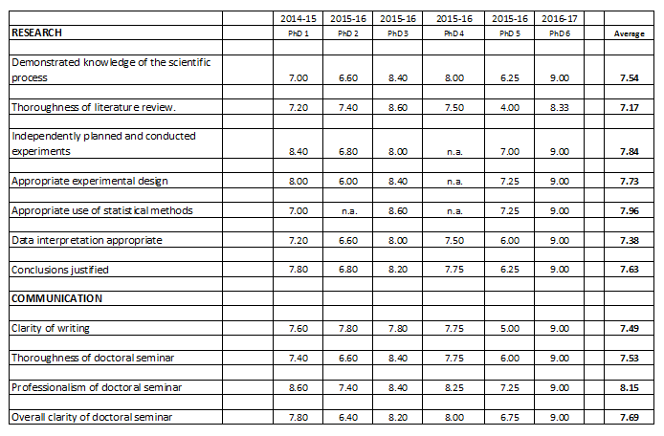

Interpreting Results

- Communication

    - From the graduate seminar, the 2014-15 academic year saw a large improvement in oral communication skills as noted by the higher scores, but the scores for the 2015-16 academic year went back down to the 2013-14 level. The lower scores for the 2015-16 academic year could be attributed to 3 out of 4 students being non-native English speakers whereas during the 2014-15 year 3 out of 4 students were native English speakers. This year, 2016-17, overall scores went back up somewhat; 2 doctoral students were non-native English speakers and 2 were native English speakers.

All areas showed improvements this year. In 2016-17, the overall average of 4.28 was higher than that for the Master’s level students (4.16). Doctoral students have had additional training and would be expected to deliver higher quality presentations. The areas that could benefit from additional improvements are (1) being able to adequately address questions after the presentation and (2) handling difficult situations during the discussion. Strengths of our doctoral students are the ability to justify the problem, logically develop their ideas, and integration of text smoothly with the visual aids.

    - Six students have defended their doctoral research over the past three years. There is a lot of variability between individual students; however, their overall scores were good. In terms of written communications, doctoral students scored 7.49 on clarity of writing. With respect to the doctoral seminar, students averaged 7.53 to 8.15, indicating they delivered a high quality presentation.

- Knowledge

Doctoral students must pass preliminary examinations covering knowledge appropriate to their field of study. These exams are individualized. Passage indicates doctoral students possess knowledge commiserate for their degree program. This year (2016-17), three students attempted their preliminary exams and all passed them.

- Research

Of the six students who have defended their doctoral research over the past three years, average research scores ranged from 7.17 (thoroughness of literature review) to 7.96 (appropriate statistical methods). Looking at the scores in Table 2, it is apparent that student #5 was weaker, resulting in a shifting of the overall average scores lower. However, this was partially compensated by a stellar student (#6).

In comparison to Master’s level students (a separate assessment report), scores for the doctoral students were higher indicating a higher level of understanding and using research. Calculating an overall average research score resulted in the doctoral students (n=6) scoring 7.61 while the Master’s students (n=11) scored 7.24.

- Teaching

Data regarding teaching assistant performance is usually gathered in the early Fall semester; thus, current year data has not been collected. Data for this new SLO will be incorporated in the 2017-18 assessment report.

Communicating Results
[Please provide a very brief narrative describing with whom the results are shared (e.g., all program faculty).]

The previous year’s report (2015-16) was shared with all departmental faculty via email on July 1, 2016, and discussed during regularly scheduled faculty meetings. The current year’s data were shared with faculty and discussed at our June 2, 2017, faculty meeting. The final report was emailed to all faculty for feedback prior to submitting to Academic Assessment.

Use of Results

Purposeful Reflection and Action Plan

Doctoral students are completing our program successfully and meeting the expected student learning outcomes.

Although faculty members oppose a standardized preliminary exam, another idea raised during the discussion involved the potential use of a numerically scored (rather than pass/fail) preliminary exam. Although this strategy would better quantitate data, the ability to use that data for improvements is questionable due to the individual nature of the preliminary examinations.

Another idea suggested was to include assessing the extent of interdisciplinary activities in which a doctoral student participated. Encouraging interdisciplinary research would be beneficial for doctoral students. However, this idea was not universally accepted due to the vast array of different research areas and ambiguity around the term “interdisciplinary”.

A discussion involving the inclusion of a new SLO (teaching experience) gained support and is now included as SLO 4. Assessment of this SLO will use our existing graduate teaching assistant evaluation form. The timing of data collection will need to be adjusted. We gather this data in early fall to meet the Graduate School’s mid-October deadline, but that does not provide us with the data for the assessment report deadline of July 1.

As with last year, the sample size is very small (n=6 over three years). Due to this small sample size, more data should be collected before major changes are considered.

