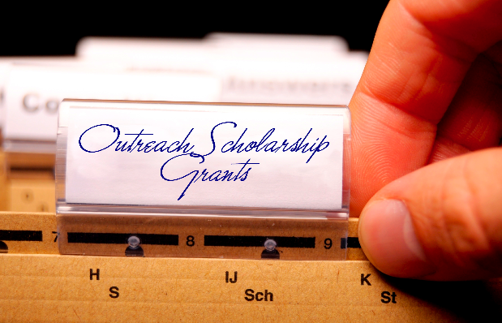

Application Requirements:

All applicants must utilize this application proposal form and the excel budget proposal form (both accessible at http://www.auburn.edu/outreachgrants ). Do not include this page as this first page of the proposal. The first page of the proposal should be a cover letter on letterhead. The proposal application form (beginning on page 2 of this application, including page header) and the excel budget form combined should not exceed nine pages. The nine page limit does not include supporting documents. Please include all supporting documents at the end of the proposal. The proposal application form, excel budget proposal form, and all supporting documents should be combined and converted into one multi-page proposal PDF file before submission. Proposals received using any other format or exceeding the specified page limit, will not be eligible for committee review. Proposals not submitted as one multi-page PDF document by the aforementioned deadline will not be eligible for committee review. Please refer to the call for proposals checklist before submitting a proposal.

Contact Information:

For further information, please contact the Director of Faculty Engagement, Dr. Chippewa Thomas at thoma07@auburn.edu via email or call (334) 844-5700. For administrative assistance, contact Gail Gauntt at gauntgd@auburn.edu or (334) 844-5700.

Proposal submissions deadline at the http://www.auburn.edu/outreachgrants website is Monday, November 10th, 2014 by 4:45 p.m. The proposal should be organized as follows.

Cover Letter:

On letterhead addressed to

2014-15 COSG Committee
c/o Dr. Chippewa Thomas, Director of Faculty Engagement
Office of the Vice President for University Outreach
Auburn University

Engaged Principal Investigators:

Please add other investigators if more than two

Name: Name:

Department: Department:

College/School/Unit: College/School/Unit:

Campus Address: Campus Address:

Campus Phone: Campus Phone:

Email: Email:

Proposal Title:

- Title. Named title of the proposed project.

Proposal Abstract:

- Abstract. (no more than 300 words). This is a brief overview stating the need and objectives for the project.

Project Need: (20%)

- Need. Describe the problem or opportunity that you wish to address. Explain how this problem opportunity of need responds or is inclusive of diversity. Be specific regarding location(s) of the project and the specific constituency affected. Describe how partnerships have or will be formed and what group/agency will be partnered and collaborated with to address the need described.

Project Method: (25%)

- Method. What do you propose to do to address the need? List major activities/milestones and completion dates.

Project Mission: (10%)

- Mission. How does the project serve the university, a university strategic plan priority and/or unit missions (e.g., outreach, diversity, community engagement, etc.)?

Project Scholarship: (10%)

- Scholarship. How does the proposed project draw upon the professional expertise of the participating faculty and personal? How will it benefit and inform the teaching and/or research of the participating faculty and personnel? Provide 3-5 scholarly references that provide a theoretical/empirical/best practice justification or basis for the project.

Project/Program Evaluation: (15%)

- Evaluation. How will you measure the impact of this initiative on the targeted audience? How will you know when/if the project goals and objectives have been met? (The measure of impact should be appropriate to the project. They may be quantitative or qualitative, or mixed method.) How will the results or outcomes be disseminated? Are there plans to pursue IRB approval, where appropriate? What impact will the project have on the targeted audience, and on Auburn University?

Sustainability Plan: (20%)

- Sustainability Plan. Support from extramural funding sources is important for sustainability and for demonstrating commitment longevity to the project. Discuss plan for project sustainability and identified funding sources for project continuation.

Additional Support and Funding:

- Additional Aid. Contributions from partners are important for leveraging resources and for demonstrating commitment to the project. Matching contributions from both an academic unit and an external constituency are especially desired. In-kind contributions are accepted. Each match should be accompanied by a letter of commitment. Part of the selection process is a cost/benefit analysis. Projects which use the grant as seed funds to establish an ongoing revenue producing program are desirable.

Qualifications of Faculty and Personnel:

- Qualifications of Faculty and Personnel. Include a brief (no more than 200 word) biographical sketch highlighting qualifications of principal and/or co-investigators and personnel for the proposed project. Attach a full CV for the principal investigator(s).

Project Budget:

- Budget (use excel form provided on website). List amount proposed. Show all planned expenditures and sources of funds.

Supporting Documents:

- Documents
  - Brief (3-5 page) vitae of principal investigator(s).
  - Letter of support from academic unit (Department Head, Director or Dean).
  - Letter of support/ engagement from target constituency.
  - Other letters committing matching resources if not included in aforementioned letters.
  - Any other supporting documents.

