ENERGETIC ENZYMES

Enzymes are proteins found in all living cells and help to speed up naturally occurring reactions by functioning as organic catalysts. Enzymes have many important functions. For example, enzymes break down proteins into amino acids so they can be absorbed by the small intestine. Other enzymes convert specialized fats called cholesterol into reproductive hormones such as estrogen and testosterone. Enzymes even break down toxic substances produced as normal byproducts of cellular respiration. Enzymes are not consumed during the reactions they catalyze. Once the final product is released, the enzyme is available to pick up additional substrate and catalyze another reaction. Enzymes are substrate-specific. Only one type of molecule can fit into the active site of the enzyme and facilitate the completion of a specific reaction.
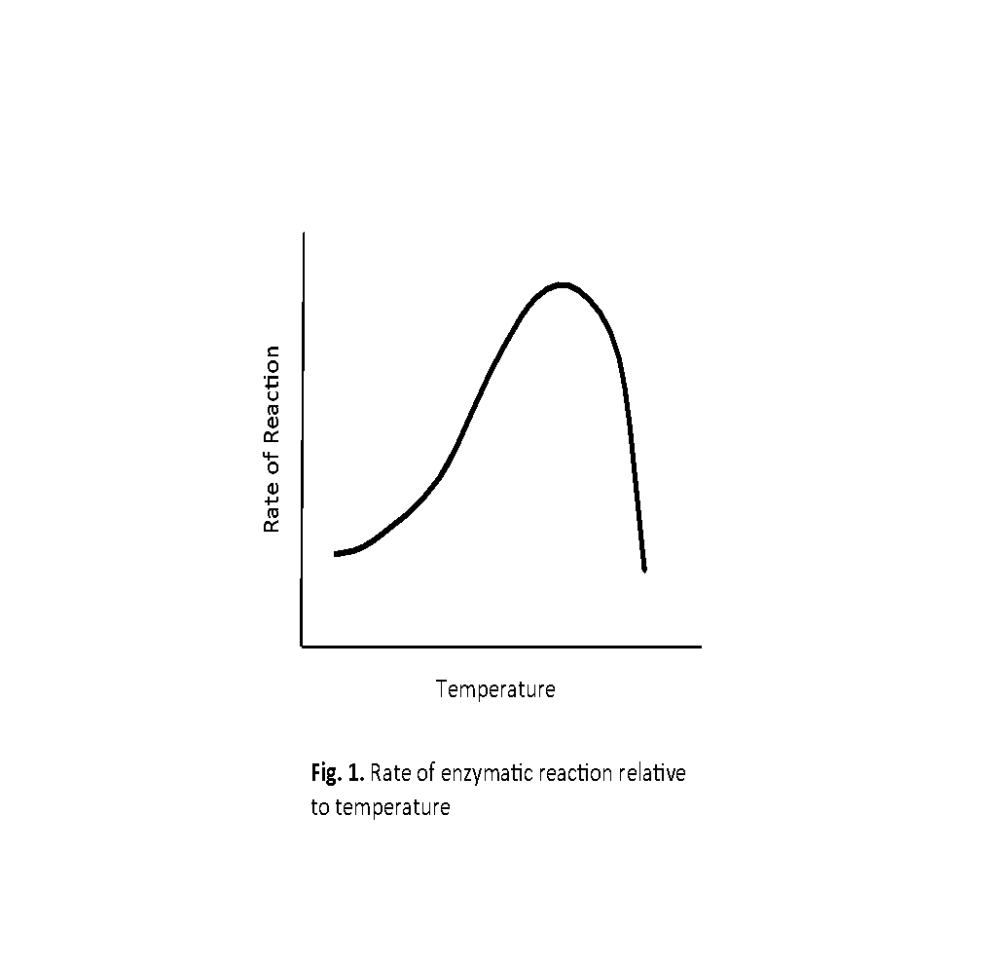
Catalase is a common enzyme that occurs in the cells of all but a few living organisms. Catalase is most abundant in intracellular organelles called peroxisomes where it assists with the breakdown of hydrogen peroxide, a toxic product of cellular respiration and other cellular processes. During cellular respiration, electrons regularly leak from the electron transport chain. These electrons are highly reactive and can produce compounds that damage cells. Hydrogen peroxide is created as a downstream product of these reactive electrons interacting with oxygen. Although hydrogen peroxide can slowly break down on its own, catalase speeds up the reduction of hydrogen peroxide to water and oxygen. The chemical equation for this reaction is:
2H₂O₂ → 2H₂O + O₂

As a result of this reaction, catalase reduces the amount of damage that hydrogen peroxide does to cells. Catalase is a type of antioxidant, or compound that neutralizes the toxic products which are created when electrons escape the electron transport chain. Antioxidants act to maintain homeostasis in cells. Catalase, like all enzymes, has an optimal temperature and pH at which they have maximum efficiency. Enzymes found in most human cells typically work best at 37ºC and pH 7. The relationship between enzyme reaction rate and temperature is represented by a skewed curve (Fig. 1).
Enzymes do not react as quickly at temperatures below their optimum and enzymes stop working at temperatures above their optimum. When an enzyme's environment becomes too hot, its protein structure unravels, and the enzyme will no longer function. This process is called denaturation. Once an enzyme becomes denatured, it will not function properly.
At Auburn University, Dr. Wendy Hood and her students study the role that mitochondria play in the aging process. Mitochondria are responsible for both producing ATP that the body uses for energy, and the mitochondria produce damaging compounds that are thought to cause aging. When electrons escape the electron transport chain and bind oxygen or nitrogen, they make damaging compounds called free radicals. Free radicals can damage intracellular membranes, proteins, and DNA. However, cells have evolved a way to protect themselves from most of this damage. Specifically, the cell produces specialized enzymes called antioxidants that break down free radicals into compounds that are less toxic.
In Dr. Hood’s lab, she and her students measure several different antioxidants that cells produce. One of the antioxidants her lab measures is catalase, the same enzyme that you will measure in class. Catalase concentrations vary with temperature. Catalase concentration also varies in different organs of the body and it varies in response to free radical production. Catalase works best at 45ºC in mammals. As you would predict, some studies have shown that catalase activity increases with heat stress, so long as the body doesn’t exceed 45ºC. And, the body stops producing catalase when body temperature drops to near zero, as occurs in hamsters and ground squirrels entering hibernation.
Typically, catalase production increases in cells as free radical production increases. The cells of the liver have a lot of catalase associated with the role of the liver in supporting detoxification. The liver also plays an important role in breaking down fats and proteins and synthesizing glucose. Dr. Hood’s lab has found that the catalase levels in the liver of old female mice that have many litters of pups are greater than old female mice that never reproduced. This finding suggests to us that old females that reproduced are also likely to be producing more damaging free radicals than females that never reproduced. These free radicals are one possible source of damage that can contribute to aging.

Review. Answer the following questions and reference the line number in the text that the answer came from.
- What is an enzyme?
- Enzymes can be denatured at high temperatures and by low or high pH. Why does the enzyme cease to function when it is denatured?
- Almost all cells produce the enzyme catalase. In the reaction below, label water, the enzyme, hydrogen peroxide, and oxygen. catalase
2H₂O₂ 2H₂O + O₂

