Notes for Teachers – Data Analysis Lab
Last updated February 13, 2020. © W. Hood, A. Haley, and R. Balkcom, Auburn University

This laboratory and material on our webpage, www.MitoEducationResearch.com, are designed to inspire high school students and their teachers by connecting the biological concepts they learn in the classroom with scientific research.

Subjects covered (reading and lab):
Sample size, mean, standard deviation, graphing

National Scientific and Engineering Practices:
Scientific and Engineering Practices:
- Asking questions
- Planning and carrying out investigations
- Analyzing and interpreting data
- Using mathematics and computational thinking
- Obtaining, evaluating, and communicating information

Appropriate for: 7-12 grade biology
Lesson Duration: 60 minutes
Group Size: 2 students
Introductory materials for teachers and use in the classroom:
Visit the website (https://www.mitoeducationresearch.com/teachers-1) to download a PowerPoint that you can use in the classroom and link to a YouTube video that will walk you through the introductory materials. The video was created by a high school teacher who worked on the project and includes suggestions based on their experience in the classroom.

Science literacy reading assignment:
The student reading materials may be downloaded from the teacher section of the webpage or you can encourage the students to read the material online in the student section (https://www.mitoeducationresearch.com/students-1). In addition to reading the science literacy materials online, students can explore the other pages, photos, and videos of Dr. Hood’s research. The webpage is designed to help students see connections between each of the labs and scientific research being conducted at a university and to help them to envision a career in scientific research. The downloadable readings include comprehension questions to test reading literacy.

The answer to question 2 in the reading is: mean = 2.8, standard deviation = 1.7

Editable files:
Two versions of the labs are provided, a pdf version and an MS Word version. Further, the MS PowerPoint is an editable file. Teachers are encouraged to review each and modify the Word and PowerPoint document to suit use in your classroom.

MATERIALS AND EQUIPMENT:
Ruler

Recommendations for successfully completing the lab.
Consider completing comparable calculations with the penny drop, toilet paper, or any other lab you do in the classroom that results in multiple students or groups collecting independent data.

When asking the students to design the experiment, you may consider bringing up the following questions/concepts – if not in definition, at least in concept.
- How are you going to reduce random error and eliminate systematic error?
  - Random error is an error in measurement caused by factors that vary from one measurement to another. This error could be associated with starting measurement of students’ palms at a very slightly different location with each measurement.
  - Systematic error is an error having a nonzero mean so that its effect is not reduced when observations are averaged. If a group of students had a ruler that has 2 mm trimmed off the left side of their ruler, they would introduce systematic error into the class dataset.
  - To reduce systematic error, pick clearly definable landmarks on the hand to measure from. Measure across the width of the knuckles because the bone cannot be easily compressed. Students should press their fingers together to keep from expanding the knuckles. You can ask students to come to these conclusions by asking them to try different measurements of their palm and select the one they can measure most consistently. You could also have a discussion about how to use a ruler – if there is a space between the left side of the ruler and the zero line, how would their data be impacted if they measure from the left side of the ruler rather than the zero line.
- Will the data the class gathers be continuous or discrete?
  - Continuous data has an infinite number of potential measurements over a given range. Height and palm width are examples of continuous data.
  - Discrete data are based on counts. The number of students in your class is an example of discrete data.
- Assume the data you collect will form a normal distribution curve and that the class represents a random sample. Why is this important?
  - A normal distribution is a function that represents the distribution of many random variables as a symmetrical bell-shaped graph. If your class has a number of cousins and brothers from a particularly tall family, the heights (and palm widths) of your class may be skewed to the right, having relatively more tall than intermediate sized students. It's important that the data is normally distributed or it will not represent a pattern that is common in human populations.
  - A random sampling is a sampling method in which all members of the group have an equal and independent chance of being selected. If only the tallest member of each group of students measures their hand, then the data collected would deviate from random.

Sample data:

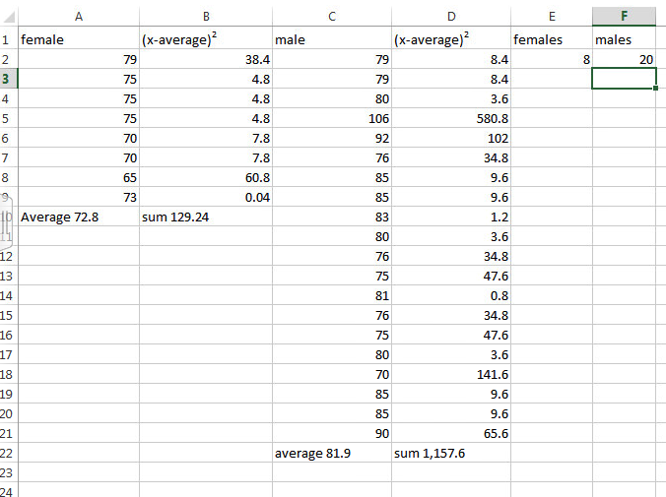

The development of this material and webpage were funded by a National Science Foundation Grant to W.R. Hood: NSF-CAREER 1453784.

