CELLULAR RESPIRATION

Metabolic rate is a measure of how much ATP humans and other animals use over time. This variable determines how much food the animal needs and how efficiently the animal performs. There are several different ways to measure metabolic rate. These measures are all based on knowledge of the equation for cellular respiration.

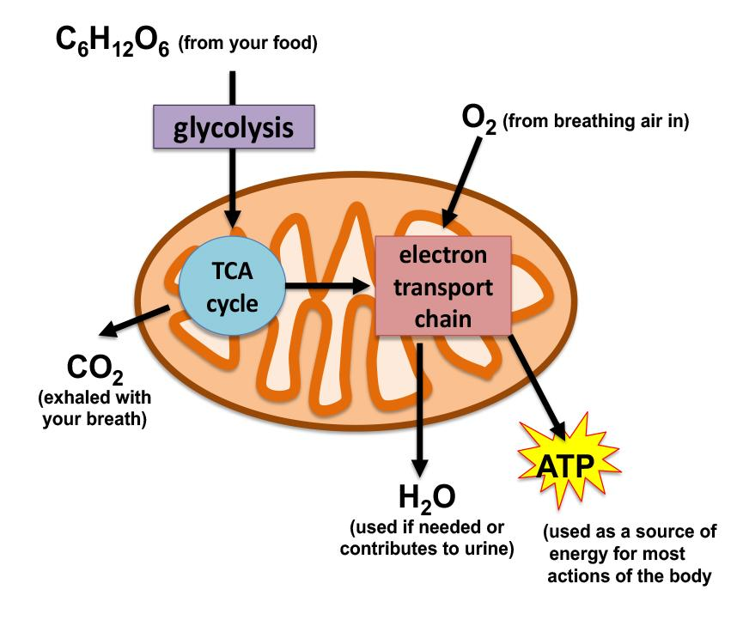
C₆H₁₂O₆ + O₂ CO₂ + H₂O + ATP
How much oxygen your body uses and how much carbon dioxide, water, and ATP it produces is determined by the total requirements of every mitochondrion in your body. The body delivers glucose from your diet and oxygen from the air that you breathe to all of the body's cells via the bloodstream. Once in the cells, glucose is transformed during the process of glycolysis and the product (acetyl-CoA) enters the mitochondria to fuel the citric acid cycle (i.e., Kreb's cycle). The products of the citric acid cycle (NADH and FADH₂) fuel the electron transport chain. CO₂ is produced by the citric acid cycle, and the electron transport chain uses O₂ to produce water before the mitochondria finally make ATP. ATP is used immediately to support the body’s need for energy. When ATP is used, heat is produced.

ATP ADP + P + heat
To measure metabolic rate, we could feasibly measure the change in any variables in the cellular respiration equation or the equation for the use of ATP. Metabolic rate is most commonly measured by quantifying how much heat is produced when the body uses ATP or how much oxygen an animal takes from the air and/or how much carbon dioxide it exhales.
In the respiration lab, you will measure how the production of one of these respiratory gasses (oxygen or carbon dioxide) changes with exercise. Which gas you have measured or how exercise impacts metabolic rate is for you to deduce when you complete the lab.
The Hood lab at Auburn University studies how different activities impact cellular respiration. For some studies, they measure oxygen use and carbon dioxide production by animals, much like you will measure in lab. For other studies, they measure the performance of mitochondria directly. In a recent study, the Hood lab showed that female mice that ran on a running wheel each day for a month had more mitochondria in several of their organs than female mice that did not have a running wheel, and the mitochondria in their skeletal muscle used oxygen more efficiently. Because of these changes, the mice that ran could produce more ATP, and thus, they could allocate more energy to different activities than females that did not run. When the mice that ran reproduced, they had more pups than those mice that did not run. These findings show that exercise can improve cellular respiration, and these changes improve the performance of mice, not only when they run, but also when they perform other activities as well.
In your lab, you will measure the production of respiratory gasses with exercise for students in your class. If you compare a male and female of the same height and body mass, the male will typically have a higher oxygen consumption and ATP production. Males have higher oxygen consumption because the male hormone testosterone stimulates greater muscle development and muscle cells have more mitochondria than many other organs in the body. In addition, testosterone appears to stimulate cells to produce larger mitochondria that have more electron transport chain complexes. To assess variation in metabolism between individuals, researchers typically control for body size in their comparisons between individuals, or more specifically, they divide oxygen intake or carbon dioxide output by the size of the person or animal.

Review. Answer the following questions and reference the line number in the text where you found the answer.

- How is carbon dioxide removed from the body?
- What are the names of the three major processes that contribute to the conversion of glucose to ATP?
- Based on the graphs of Dr. Hood’s data, approximately how many more pups did females that had a running wheel have?

