The Caloric Content of Food and its Application to Mitochondrial Respiration

Why do you need food? To gain energy. Cellular respiration is the process by which the chemical energy from the molecules in the food is captured for use by your body. The carbohydrates, fats, and proteins in your food are broken down to produce compounds that are used by the cell’s mitochondria to produce ATP via cellular respiration. When a specific bond in the ATP is broken, energy is released. Glucose (a carbohydrate) provides the simplest and most efficient example of the reactions involved in aerobic respiration:
C₆H₁₂O₆ + 6 O₂ 6 CO₂ + 6 H₂O + energy
The amount of heat produced during the combustion, or burning of a compound with oxygen, is used to determine its energy content. The unit that is most commonly used to measure the energy content of food is the Calorie (upper case C). This is the unit you will find in the nutrition facts box on a food label. Scientists use the unit calorie (lower case). A calorie is equal to 1/1000 of a food Calorie (i.e. 1 kilocalorie = 1 Calorie). Thus, the Calorie content of a food is really a measure of how much heat it gives off when it burns. In your body, when ATP is used this energy is harnessed to do work.
The more energy, or calories, in the food item, the greater the amount of heat it produces when it burns. In cells, higher calorie food produces more heat and low-calorie foods produce less heat. Thus, high-calorie food can support more work than low-calorie food. Energy in the form of ATP is used to power processes such as growth and muscle contraction. In class, you will estimate the relative energy content of food items based on how much heat it generates as it burns.
Energy content of macronutrients
Carbohydrate | 4 kcal/g
Fat | 9 kcal/g
Protein | 4 kcal/g
Of the macronutrients in your food, carbohydrate, fat, and protein, fat provides the most energy per gram. Thus, when combusted, fat should produce the most heat. Interestingly, because your body isn’t very efficient at processing fat and it is very efficient at processing carbohydrates like glucose, your body makes about the same number of ATP from 1 gram of carbohydrate and 1 gram of fat.
In the Hood Laboratory at Auburn University, Dr. Hood and her students use an instrument called a bomb calorimeter to measure the energy content of food items. While very precise bomb calorimeters that are used by scientists in their research are quite expensive, it’s possible to build a bomb calorimeter in the classroom that works relatively well. Heat dissipates more slowly from water than from the air, so one of the best ways to measure heat loss from an item, such as food burning in a bomb calorimeter, is to capture the heat in
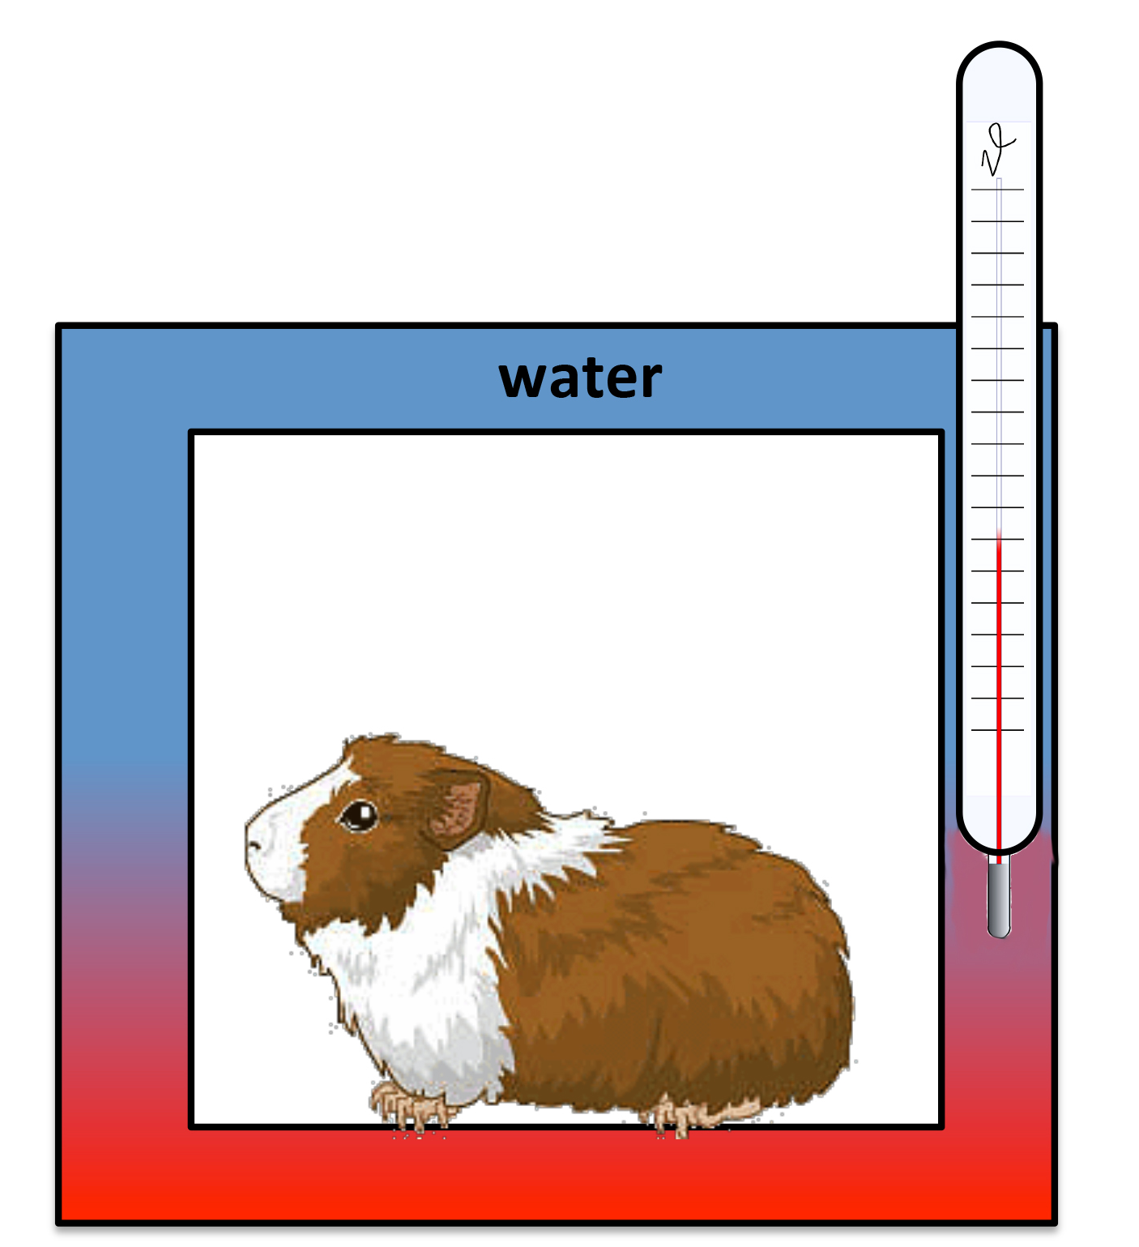
30 water. The calorimeter you will be building in class uses this same strategy.
31 The change in temperature of the water from before to after it ‘captures' heat from a
32 burning food item can be used to calculate its calorie content. Incidentally, the same
33 method can be used to measure the energy used by a person or other organism. The
34 first calorimeter was used to measure the heat production, or energy used, by a
35 guinea pig in 1780 by Antoine Lavoisier. No burning is required when measuring
36 energy production by a live organism. Instead, when an organism breaks ATP as a
37 source of energy, heat is generated. Thus, to measure the energy use by a whole
38 animal, the animal is temporarily put in a box that is insulated with water. The heat
39 generated by the animal increases the temperature of the water, and from that
40 change in temperature, the amount of energy that the guinea pig used while in the
41 chamber can be calculated. Dr. Hood and her students can use a bomb calorimeter to determine how much fuel that food will provide an animal to support the production of ATP by the mitochondria. Many investigators measure how much oxygen animals use rather than how much heat they produce as an indicator of their relative energy expenditure. You will learn more about how to measure energy expenditure in the cellular respiration lab, if time allows.

Review. Answer the following questions and reference the line number in the text that the answer came from.
- How do scientists measure the calorie content of food?
- What does a bomb calorimeter measure?
- What molecule is used as a source of energy by your body? Where is that molecule made?

