MOLECULE
ATOM
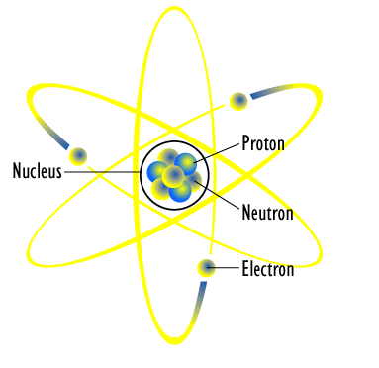
PROTEIN

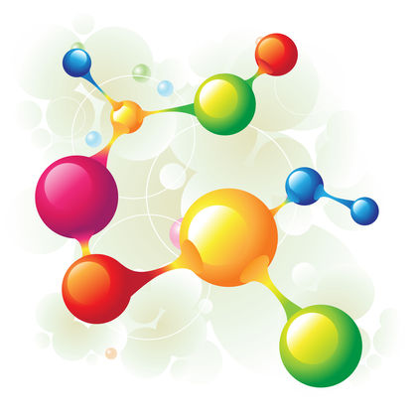
CELL
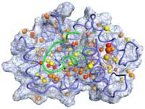
ORGAN
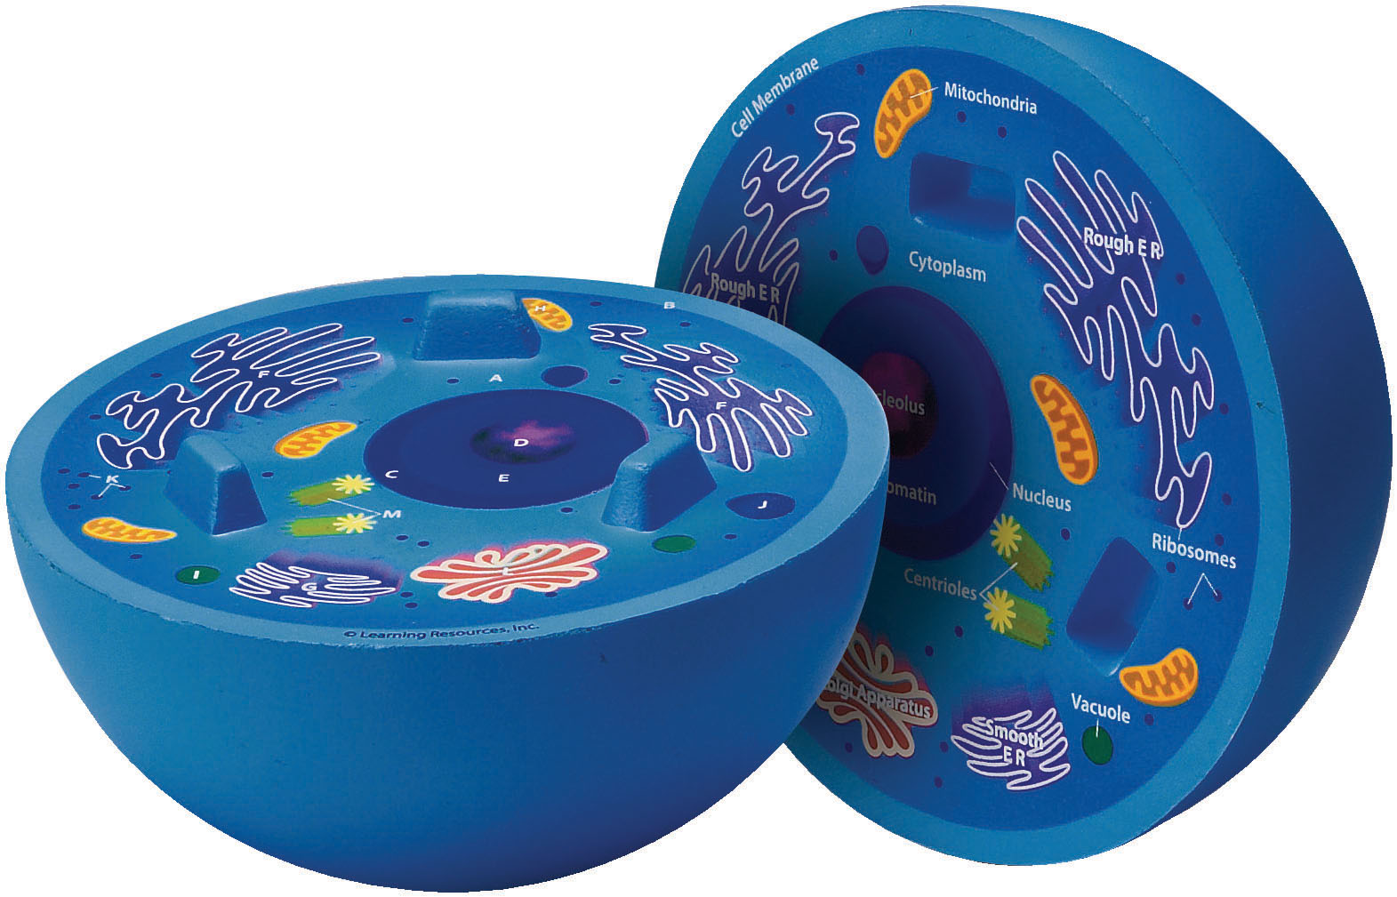
ORGAN

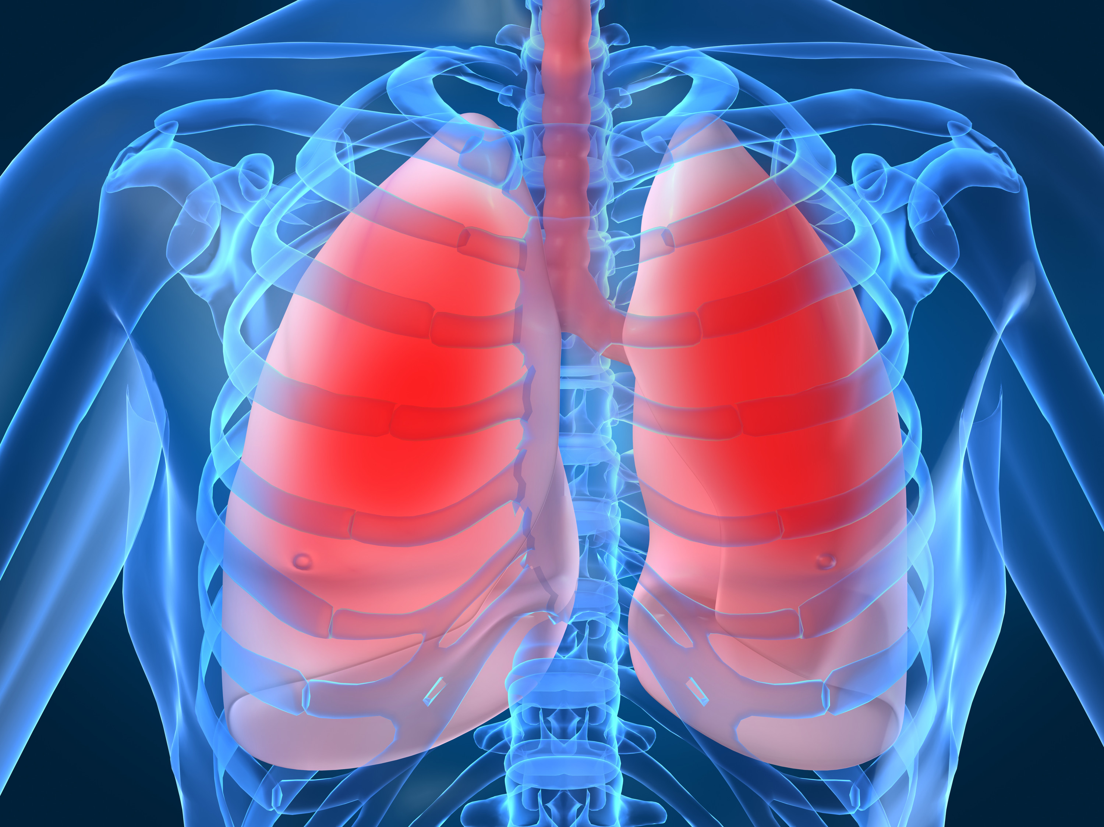
TISSUE
ORGAN
SYSTEM
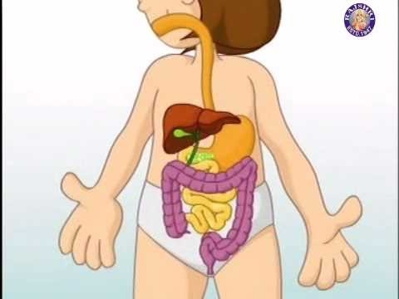
Photos retrieved from:

http://www.atomicheritage.org/mediawiki/images/d/d8/Atom_diagram.png

http://www.scienceclarified.com/Ma-Mu/Molecule.html

http://www.uphs.upenn.edu/news/News_Releases/jul07/protein-internal-motion.html

http://www.crsd.org/Page/27877

http://taodol.com/Organs.aspx

http://indulgy.com/post/uZ6FGHrAC1/the-digestive-system-and-link-to-many-more-grea

