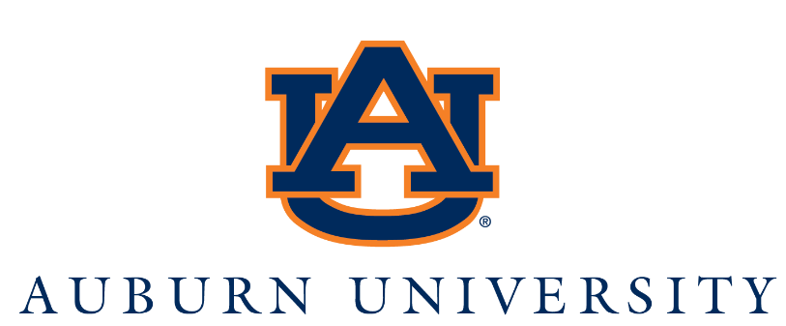
President
The Board of Trustees of Auburn University seeks its 21st president, a person of integrity and vision who will lead our multifaceted institution to even greater prominence. The next president of the state’s R1 land-, sea-, and space-grant institution will oversee the Auburn University main campus located in Auburn, Alabama; Auburn University at Montgomery, a separately accredited campus located in the state’s capital (Montgomery, Alabama); the Alabama Agricultural Experiment Station; and the Alabama Cooperative Extension System, a joint enterprise with Alabama A&M University. The leader will marshal the institution’s $1.54 billion budget and vast resources, spearheading the university’s strategic vision and economic development. Auburn finds itself at an exciting crossroads, celebrating achievements and planning for continued growth. The next president will have the ability to foster excellence in our 31,000 students, our exceptional faculty and staff, and our dynamic alumni base. The university seeks a bold visionary who appreciates and respects Auburn traditions while energetically leading the university toward an accomplished future. As a Southeastern Conference charter member, Auburn has a strong reputation of athletic prestige, including numerous national championships in men’s and women’s sports.
The 21st president of Auburn University has a historic opportunity to shape the direction of one of the nation’s leading public research universities. The preferred candidate will work with faculty, students, staff, and alumni to promote a shared vision of higher education dedicated to research excellence and an exceptional student experience. This president will take office with a charge to lead Auburn into a vibrant future.
The next president will be an experienced and visionary leader, as well as an accomplished scholar who understands that research and teaching excellence, together with service and public engagement, are at the very heart of the land-grant university. The president will employ wise stewardship of resources, talent, and innovation. Passionate about the promise of economic opportunity and social mobility afforded by an outstanding education, the president will possess a clear and articulate understanding of the indispensability of diversity, equity, and inclusion in the workplace and the classroom. A proven, capable, and experienced administrator, the president will encourage and support research, teaching, and public service as instruments of growth and economic development. The president will advocate for Auburn University with community partners in the business and civic sectors. In preparation for the next comprehensive university fundraising campaign, the president will serve as the “face of fundraising” for the university. The president will be expected to engage and encourage donors and alumni to maintain a lifelong supportive relationship with Auburn University, fostered by outstanding academic and athletics programs of the University.
A visionary leader, the president will be committed to nurturing within Auburn’s students the best critical- and creative thinking skills and equipping them with the expertise they need to succeed in the changing landscape of work and citizenship. The next president must be a thoughtful thinker, a cooperative problem-solver, and will have an opportunity to articulate a renewed sense of purpose for all stakeholders committed to sustaining Auburn University as the exemplar of a public land grant university. The next president will have the commitment, vision, entrepreneurial skills, and ability to foster growth of the research enterprise and the infrastructure to support it, ensuring its quality and competitiveness, and its contribution to economic development.
The president will ensure that the university anticipates the future with energy, enthusiasm, and a vision. Working with a variety of partners, the president will shape short- and long-term strategies to guarantee that Auburn University not only embraces the challenges of the next 150 years but defines the role of public higher education in addressing them, as well.

For more information, visit the Auburn Presidential Search website.

How to Apply
Greenwood/Asher & Associates, Inc. is assisting Auburn University in this search. Applications and nominations are now being accepted. For a full application package, please include a cover letter, CV and list of five references. Confidential inquiries, nominations and application materials should be directed to Greenwood/Asher and Associates. Submission of application materials as PDF attachments is strongly encouraged. Initial screening of applications will begin immediately and will continue until an appointment is made.

Inquiries, nominations, and application materials should be directed to:
Jan Greenwood, Founder, Greenwood/Asher & Associates
Vice President and Managing Partner, Kelly
Betty Turner Asher, Founder, Greenwood/Asher & Associates
Vice President and Managing Partner, Kelly
Julie Holley, Senior Executive Search Consultant

E-mail: jangreenwood@greenwoodsearch.com
E-mail: bettyasher@greenwoodsearch.com
E-mail: julieholley@greenwoodsearch.com

Auburn University is committed to an inclusive and diverse campus environment.
Women, underrepresented groups, individuals with disabilities and veterans are encouraged to apply.
AUBURN UNIVERSITY IS AN AFFIRMATIVE ACTION / EQUAL OPPORTUNITY EMPLOYER.
It is our policy to provide equal employment opportunities for all individuals without regard to race, sex, religion,
color, national origin, age, disability, protected veteran status, genetic information, sexual orientation,
gender identity, or any other classification protected by applicable law.

