Food Science, BS

The undergraduate B.S. in food science is housed in the Department of Poultry Science. The food science B.S. degree is designed to prepare students for careers in the food industry or admission into graduate programs in food science. During the 2016-17 academic year, 18 undergraduate students were enrolled in the food science program.

Student Learning Outcomes

Specificity of Outcomes

SLO 1: Food Sources - Students will know the sources of food-related substances.
SLO 2: Food Ingredients - Students will be able to explain the functionality and interactions of food ingredients within a food system.
SLO 3: Chemical Stability - Students will be able to describe the chemical stability of food and explain strategies for controlling degradative reactions.
SLO 4: Food Safety - Students will recognize food safety risks associated with food and describe how to control those risks.
SLO 5: Food Plant Sanitation - Students will be able to explain the fundamental principles of food plant sanitation as applied to the food industry.
SLO 6: Food Analysis - Students will be able to determine and describe methodologies for food chemical and physical analysis.
SLO 7: Food Safety Management - Students will be able to design a food safety plan.
SLO 8: Microbial Food Stability - Students will be able to describe microbial stability of food.
SLO 9: Microbiological Analysis - Students will be able to perform microbiological analyses of foods.
SLO 10: Sensory Science - Students will be able to explain sensory science’s role within food product development and methods associated with sensory evaluation.
SLO 11: Food Processing - Students will demonstrate an understanding of food processing methods.
SLO 12: Food Engineering - Students will demonstrate a knowledge of the engineering concepts and principles associated with food processing.
SLO 13: Food Product Development - Students will be able to conceptualize and develop a new food product, thereby demonstrating an understanding of the food product development process.
SLO 14: Communication - Students will demonstrate effective oral and written communication skills.
SLO 15: Problem Solving - Students will be able to solve food science-related questions/problems.
SLO 16: Professionalism - Students will interact and communicate professionally with people in the food science industry.

Comprehensive Outcomes
For the B.S. in food science, the above outcomes are comprehensive. Our professional organization, the Institute of Food Technologists (IFT), lists numerous competencies that food science students must have for a food science program to receive their endorsement (our program is approved by IFT). Food science courses and SLOs were developed based on the IFT guidelines. Reports are submitted annually to IFT.

Communicating Student Learning Outcomes
The outcomes listed above have been distributed to faculty via email and discussed at faculty meetings. We are also in the process of adding them to the departmental website so students will have access to them.

Curriculum Map

Curriculum Map

 | FDSC  1000 | FDSC  4290 | FDSC  4920 | FDSC  5430 | FDSC  5450 | FDSC  5640 | FDSC  5660 | FDSC  5730 | FDSC  5770 | POUL  5140 | POUL  5160 | BSEN  5550
SLO 1: Food Sources | 1 | 0 | V | 2 | 0 | 1 | 1 | 0 | 0 | 0 | 0 | 0
SLO 2: Food Ingredients | 1 | 0 | V | 2 | 1 | 2 | 0 | 1 | 1 | 2 | 0 | 0
SLO 3: Chemical Stability | 1 | 0 | V | 2 | 1 | 1 | 0 | 0 | 0 | 1 | 0 | 0
SLO 4: Food Safety | 1 | 0 | V | 0 | 1 | 1 | 2 | 1 | 2 | 1 | 2 | 0
SLO 5: Food Plant Sanitation | 0 | 0 | V | 0 | 1 | 0 | 0 | 0 | 2 | 0 | 0 | 0
SLO 6: Food Analysis | 0 | 0 | V | 0 | 2 | 1 | 0 | 1 | 0 | 2 | 0 | 0
SLO 7: HACCP | 1 | 0 | V | 0 | 0 | 1 | 0 | 0 | 2 | 0 | 2 | 0
SLO 8: Microbial Food Stability | 1 | 0 | V | 0 | 1 | 1 | 2 | 1 | 1 | 1 | 0 | 1
SLO 9: Microbiological Analysis | 0 | 0 | V | 0 | 1 | 1 | 2 | 1 | 1 | 0 | 1 | 0
SLO 10: Sensory Science | 0 | 0 | V | 0 | 0 | 2 | 0 | 2 | 0 | 1 | 0 | 0
SLO 11: Food Processing | 1 | 0 | V | 0 | 0 | 1 | 0 | 1 | 1 | 2 | 0 | 2
SLO 12: Food Engineering | 0 | 0 | V | 1 | 0 | 1 | 0 | 0 | 1 | 0 | 0 | 2
SLO 13: Food Product Development | 0 | 0 | V | 1 | 1 | 2 | 1 | 1 | 0 | 2 | 0 | 0
SLO 14: Communication | 1 | 2 | 2 | 2 | 1 | 2 | 2 | 2 | 1 | 2 | 1 | 2
SLO 15: Problem Solving | 1 | 1 | 2 | 2 | 2 | 2 | 2 | 1 | 1 | 2 | 1 | 2
SLO 16: Professionalism | 1 | 1 | 2 | 1 | 1 | 1 | 1 | 1 | 1 | 2 | 1 | 1

0 = no coverage; 1 = some coverage; 2 = extensive coverage; V = variable depending upon internship experience

Measurement

Outcome-Measure Alignment
Most SLOs are assessed using a combination of a pre-test/post-test, specific exam questions, or class assignments. Several rubrics have been developed to help with assessing class assignments (e.g., written communication, oral communication, projects). Item 1 shows an example of a pre-test used in FDSC 1000. Items 2-4 are rubrics used for assessing communication ability. Item 5 is a survey used by internship supervisors to assess our students.

Direct Measures

With the exception of SLO 9 (which needs an assessment tool developed), each SLO has a direct measurement.

Data Collection

For some SLOs, individual faculty members collect data for their courses, usually in the form of pre- test/post-test results. The pre-test consists of a series of questions administered in class at the beginning of the semester. The same or similar questions are re-administered later in the semester (either as exam questions, an end-of-the-semester post-test, or part of the final exam). Number of correct responses to both the pre-test and post-test on a question by question basis are reviewed by the faculty member and reported to the assessment coordinator.

Communication skills are assessed throughout the student’s program, starting with the introductory course. Rubrics are used to assess both written and oral communication skills. The faculty member completes the rubric, which is returned to the student to hopefully improve their future performance. All scores are reported to the assessment coordinator at the end of the semester.

Class projects also assess students’ abilities in FDSC 5640, POUL 5140/ANSC 4700, and POUL 5160. A rubric is used to help identify areas where students’ performance needs improving.

All food science students complete an internship most commonly in the food industry. The on-site supervisor completes a performance evaluation form on the student. The survey is provided as a google document which is completed online. The evaluation is completed at mid-semester with results reported to the student. A final evaluation is completed at the end of the semester.

Item 1. Evaluation tool used in FDSC 1000 to assess SLO 1.

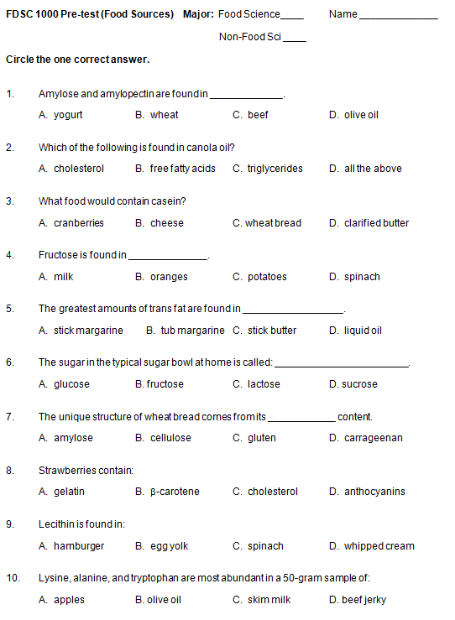
Item 2. Evaluation tool used in POUL 5160 to assess SLO 7.

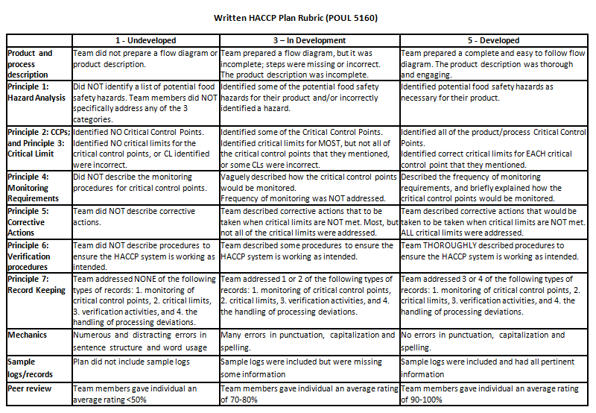

Item 3. Evaluation tool used to assess writing ability (SLO 14).

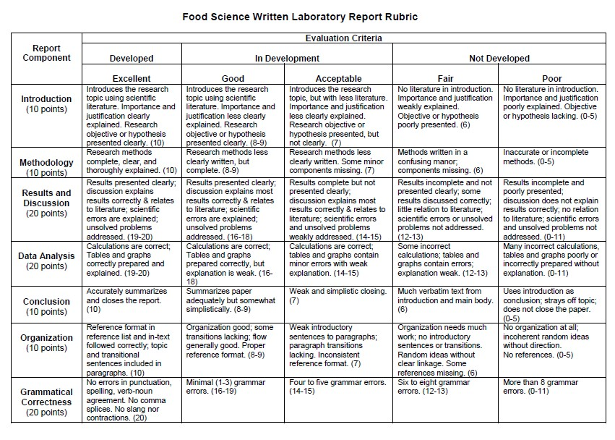
Item 4. Evaluation tool used to assess oral communication ability (SLO 14) in FDSC 5430.

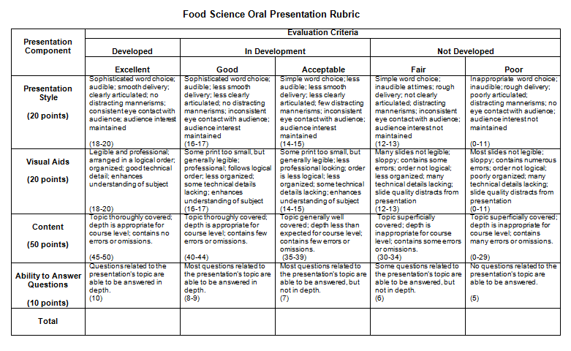
Item 5. Evaluation tool used by internship supervisors to assess SLOs 14, 15, and 16.

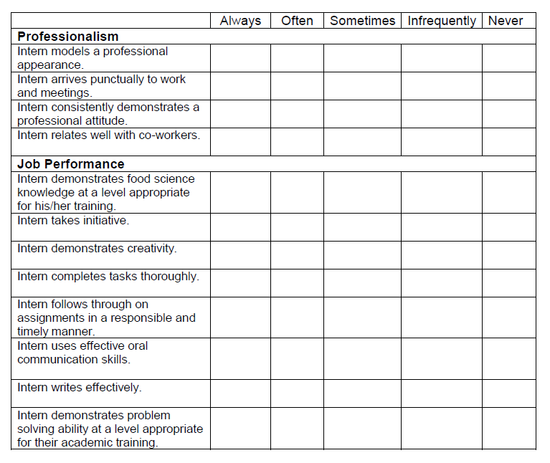

Results

Reporting Results

  - Data from the pre-test/post-test for SLO 1 (food sources) are presented in the following table for food science students only. Ratios are correct responses per total responses.

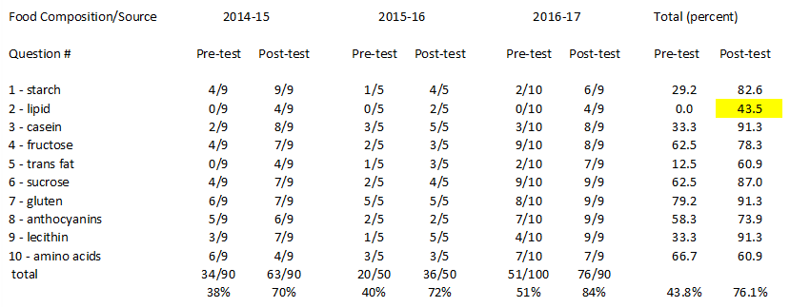

  - Data from the pre-test/post-test for SLO 2 (food ingredients) are presented in the following two tables. For the 2013-14 and 2014-15 academic years, the assessment tool was in the form of multiple choice questions. Ratios represent correct responses per total responses.
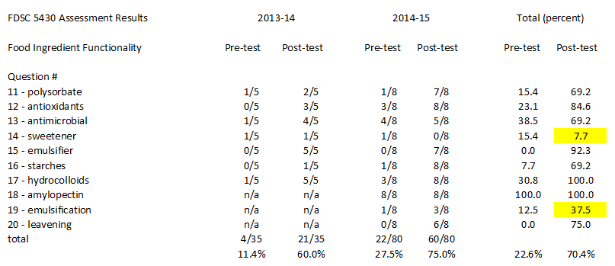

  - Data from the pre-test/post-test for SLO 3 (chemical stability) are presented in the following two tables. For the 2013-14 and 2014-15 academic years, the assessment tool was in the form of multiple choice questions. Ratios represent correct responses per total responses.

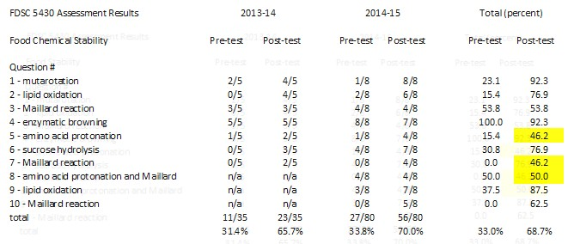

For the 2016-17 academic year, the assessment tool was changed to be free response to better evaluate knowledge retention in regards to specific aspects of each reaction. The results of the revised pre- and post-tests are shown below.

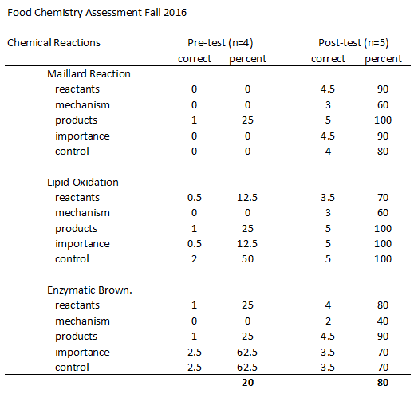

  - Data from the pre-test/post-test for SLO 4 (food safety) are presented in the following table for food science students only. Ratios are correct responses per total responses.

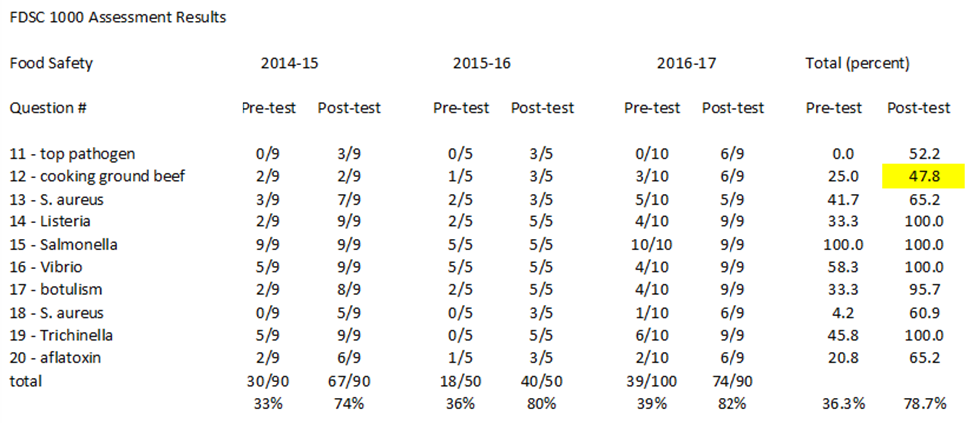

A pre-test/post-test was also given in POUL 5160 (Principles of Food Safety), however only one food science student was enrolled during the 2016-17 academic year and the student was not present for the pre-test. Thus, the data are not tabulated for that single student.

  - Data for SLO 5 (food plant sanitation) are presented in the following table. Ratios are correct responses per total responses. FDSC 5770 was not taught during the 2016-17 academic year so there is not updated data to report.

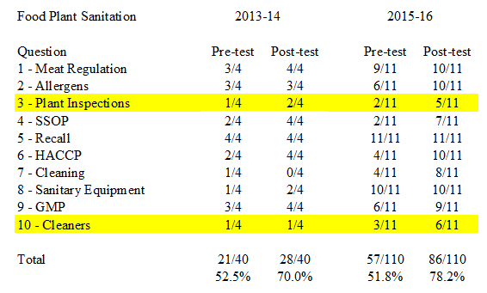

  - Data from the pre-test/post-test for SLO 6 (food analysis) are presented in the following table for the 2014-15 academic year. FDSC 5450 was not taught during the 2015-16 academic year. Unfortunately, only pre-test data were collected during the 2016-17 academic year so improvements in learning could not be ascertained. Ratios are correct responses per total responses.

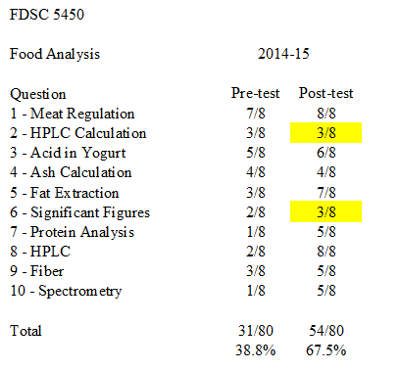

  - Students worked in groups (food science, poultry science, graduate students) on HACCP plans. Average data for the written report appear in the table below, where the scale used goes from 1 (undeveloped) to 5 (fully developed).
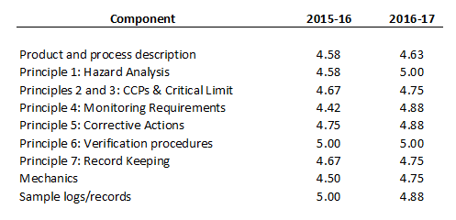
In addition, the one enrolled food science student did achieve his/her HACCP certification at the conclusion of the course during the current year (2016-17).

  - Data for SLO 8 (microbial food stability) were obtained via a pre-test/post-test assessment tool in FDSC 5660. Results are shown in the table below for the 2016-17 food science cohort (n=5). Ratios represent correct responses per total responses.

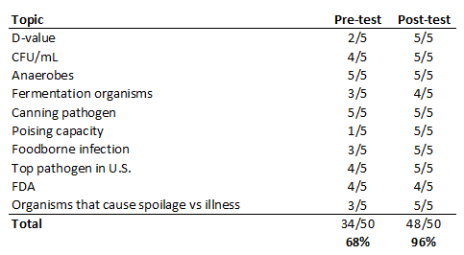

  - The assessment tool used to evaluate SLO 9 (microbiological analysis) has yet to be developed.

  - Data for SLO 10 (sensory evaluation) were obtained from an 8-question pre-test/post-test that required written short answers. For the 2016-17 academic year, 5 food science students scored an average of 12% correct on the pre-test and an average of 95% correct on the post-test.

  - Data for SLO 11 (processing) were obtained via a pre-test/post-test assessment tool in POUL 5140. Results are shown in the table below for the 2016-17 cohort (n=5). Ratios represent correct responses per total responses.

Percent of food science students (n=5) who answered the questions correctly in Pre- and Post-assessment quizzes in POUL 5140 (2016-17 academic year)

Question Topic | Pre-test | Post-test
Myofibrillar protein | 20% | 0%
Meat quality issue | 20% | 80%
Emulsified meat (T/F) | 20% | 60%
Marination | 20% | 100%
Pigmentation (T/F) | 60% | 100%
Scalding process | 0% | 100%
Chilling system | 0% | 40%
Emulsified meat | 0% | 100%
Contamination (T/F) | 40% | 100%
Breading systems (T/F) | 0% | 80%
Average | 18% | 76%

  - Data based on specific exam questions that address SLO 12 (food engineering) are shown below. Percentages represent the average scores on the particular subject matter from Fall 2015 (n = 11). BSEN 5550 was not taught during the 2016-17 academic year so there is no additional data to present.

Problem solving skills (heat exchanger): 86.8%
Physical properties: 83.3%
Material and energy balance: 89.0%
Mechanisms of heat transfer: 87.3%

  - Data from the pre-test/post-test for SLO 13 (food product development) are presented in the following table. Ratios are correct responses per total responses. FDSC 5640 was not taught during the 2016-17 academic year so there is no additional data to present.

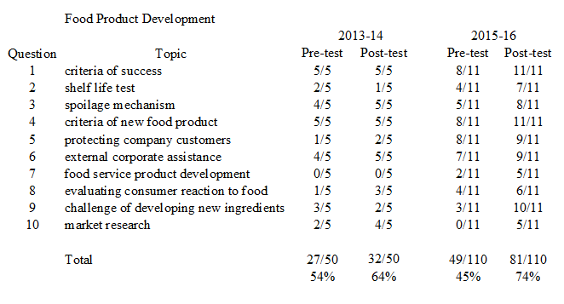

In addition, undergraduate and graduate students were divided into four groups for a semester-long product development project. Aspects associated with product development were assessed in a final report at the end of the semester. These are shown in the table below for the 2015-16 academic year.
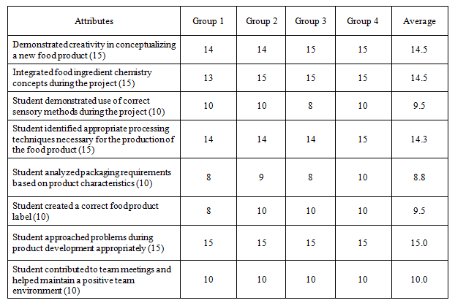

  - Communication ability (SLO 14) was assessed across multiple courses.

Oral Communication

The tables below summarize oral communication data from several classes: FDSC 4290, FDSC 5430, FDSC 5640, and POUL 5160.

Results from 25-minute oral presentation in FDSC 4290

Aspects of Oral Presentation | 2014-15 (n=9) | 2016-17 (n=4)
Problem & justification | 84% | 81%
Presented information | 85% | 86%
Visual aids | 86% | 89%
Spoke confidently | 83% | 82%
Vocabulary& grammar | 86% | 88%
Summary | 85% | 86%
Response to questions | 80% | 84%
Handled difficult situations | 79% | 82%
Leadership | 82% | 83%

In FDSC 5430, the oral communication rubric changed in the 2016-17 academic year to be more descriptive. The previous data is shown for comparison purposes.

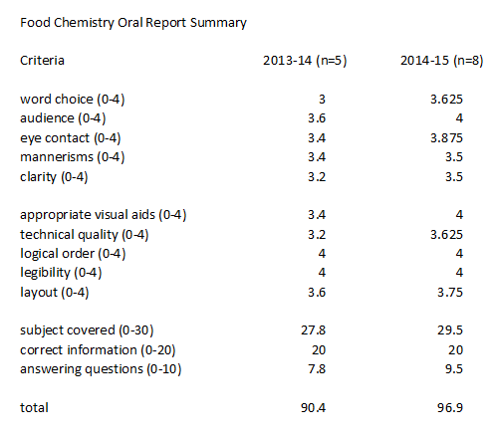

Assessment Data for Food Chemistry Oral Report (2016-17)

Presentation Component | Student 1 | Student 2 | Student 3 | Student 4 | Student 5 | Average
Presentation Style | 85% | 80% | 85% | 100% | 85% | 87%
Visual Aids | 95% | 95% | 90% | 100% | 100% | 96%
Content | 100% | 86% | 90% | 100% | 100% | 95%
Ability to Answer Questions | 90% | 80% | 80% | 100% | 100% | 90%

Assessment Data for Food Product Development Final Oral Presentation (2015-16)

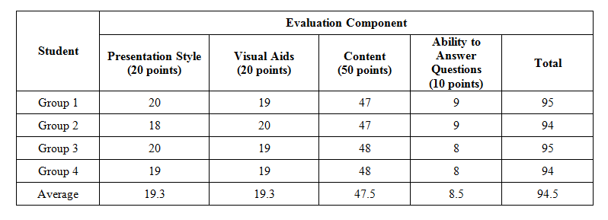

An oral report on HACCP was required in POUL 5160. The table below shows the average of group presentations, with scores ranging from 1 = undeveloped/poor to 5 = fully developed/excellent. Groups consist of food science undergraduate students, poultry science undergraduate students, and graduate students.
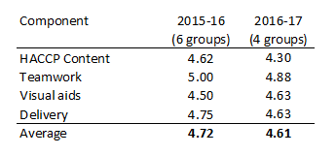

Written Communication

The tables below summarize data from various writing assignments across various food science courses and various academic years.

Sustainability Written Report Results (FDSC 1000, Spring 2015)

Student | Content A (10) | Content B (10) | Organization (5) | Grammar (10)
1 | 9 | 7 | 3 | 9
2 | 10 | 7 | 5 | 9
3 | 8 | 8 | 4 | 5
Average | 90% | 73% | 80% | 77%

International Food Written Report Results (FDSC 1000, 2016-17)

Student | Introduction (10) | Main Content (30) | Closing (10) | Reference List (5) | Grammar & Organization (15)
1 | 10 | 30 | 10 | 4 | 13
2 | 8 | 22 | 7 | 4 | 10
3 | 9 | 30 | 10 | 3 | 13
4 | 10 | 30 | 9 | 3 | 13
5 | 9 | 24 | 10 | 3 | 11
6 | 9 | 28 | 10 | 5 | 12
7 | 10 | 24 | 10 | 5 | 11
8 | 8 | 27 | 10 | 4 | 12
9 | 9 | 23 | 7 | 4 | 11
10 | 10 | 26.5 | 10 | 3.5 | 12
Average | 92% | 88% | 93% | 77% | 79%

Assessment Data for Food Chemistry Written Report

Report Component | 2014-15 (n=8) | 2016-17 (n=5)
Introduction | 100% | 100%
Main body | 89% | 74%*
Conclusion | 95% | 84%
References | 80% | 56%
Grammar & Organization | 81% | 76%*

*One student scored exceptionally low in these areas, shifting the average dramatically.

Written Laboratory Report Data from Microbiology of Meat (2015-16, n=7)

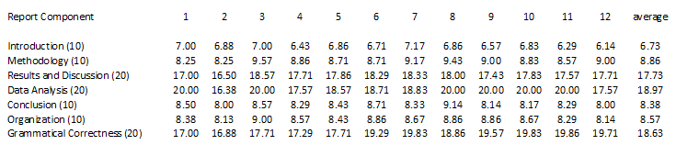

Written Laboratory Report Data (average per criteria) from Food Microbiology (2016-17, n=5)

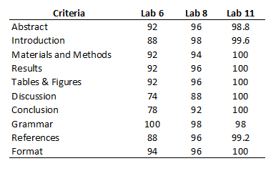

Written Laboratory Report Data from Food Analysis (2016-17, average from 10 reports)

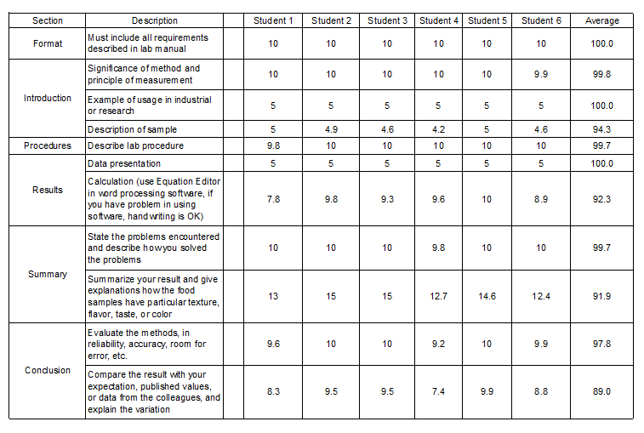

Written Report Data from Food Product Development (2015-16, n=11)

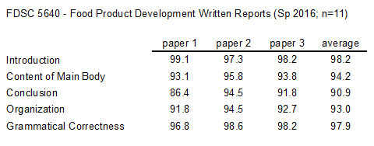

Assessment Data for Internship Written Report

Report Component | 2015 (n=8) | 2016 (n=4)
Company Information | 90% | 95%
Internship Information | 93% | 97%
Grammar & Organization | 63% | 77%

  - Problem solving ability (SLO 15) was assessed across multiple courses and through internships. Examples of data collected appear below.

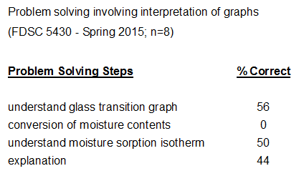

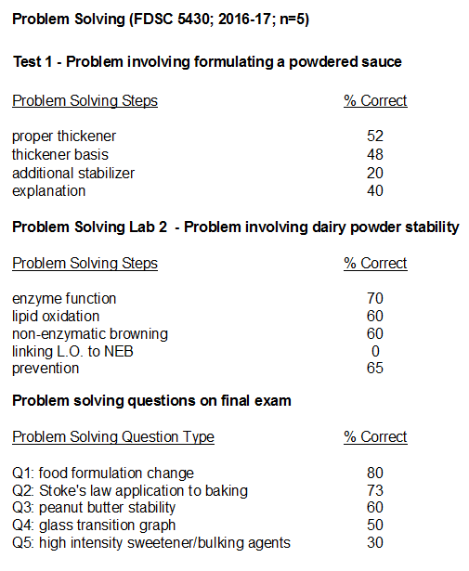

Internship supervisors in 2015 indicated that 7 out of 8 interns always used problem solving skills appropriate with their level. In 2016, 4 out of 4 interns always used problem solving skills appropriate with their level.

  - Feedback from internship supervisors as well as a reflective self-evaluation was used to assess SLO 16 as well as provide additional information on SLOs 14 and 15. The tables below shows the results from summer 2015 (n = 8 students) and summer 2016 (n = 4 students). Responses were converted to numerical scores and averaged, where 5 = always, 4 = often, 3 = sometimes, 2 = infrequently, and 1 = never.

Internship Feedback on Professionalism (SLO 16)

Professionalism | 2015 (n=8) Supervisor Eval. | 2016 (n=4) Supervisor Eval. | 2016 (n=4) Self Eval.
Intern models a professional appearance. | 4.88 | 5.0 | 4.75
Intern arrives punctually to work and meetings. | 5.0 | 5.0 | 5.0
Intern consistently demonstrates a professional attitude. | 5.0 | 5.0 | 4.75
Intern relates well with co-workers. | 4.88 | 5.0 | 5.0

Internship Feedback on Job Performance, Professionalism (SLO 16) Communication Skills (SLO 14), and Problem Solving Ability (SLO 15)

Job Performance | 2015 (n=8) Supervisor Eval. | 2016 (n=4) Supervisor Eval. | 2016 (n=4) Self Eval.
Intern demonstrates food science knowledge at a level appropriate for his/her training. | 4.88 | 5.0 | 5.0
Intern takes initiative. | 4.62 | 4.75 | 4.5
Intern demonstrates creativity. | 4.62 | 4.75 | 4.25
Intern completes tasks thoroughly. (SLO 16) | 4.88 | 5.0 | 5.0
Intern follows through on assignments in a responsible and timely manner. (SLO 16) | 5.0 | 5.0 | 5.0
Intern communicates effectively. (SLO 14) | 4.62 | n.d. | n.d.
Intern uses effective oral communication skills. (SLO 14) | n.d. | 5.0 | 4.75
Intern writes effectively. (SLO 14) | n.d. | 5.0 | 5.0
Intern demonstrates problem solving ability at a level appropriate for their academic training. (SLO 15) | 4.88 | 5.0 | 4.25

Interpreting Results

Student cohorts in food science are typically small, ranging from 5-11 students. The small sample size must be considered when interpreting the results discussed below.

- SLO 1 – Food Sources

Students improved in their knowledge regarding sources of foods and food ingredients during FDSC 1000. Post-test scores have increased over the past three years. However, the question about lipids continues to receive lower scores, indicating this topic should be covered more thoroughly in future course offerings.

- SLO 2 – Food Ingredients

Students improved in their knowledge regarding the functioning of food ingredients during FDSC 5430. The scores increased from the 2013-14 cohort to the 2014-15 cohort. The pre-test format was changed from multiple choice to free response for the 2016-17 cohort so direct comparisons to previous years’ data are difficult. The questions about benzoic acid and calcium chloride received lower scores in the new assessment tool.

- SLO 3 – Chemical Stability

Students improved in their knowledge regarding the food chemical stability during FDSC 5430. The scores slightly increased from the 2013-14 cohort to the 2014-15 cohort. The pre-test format was changed from multiple choice to free response for the 2016-17 cohort. Scores increased from 20% on the pre-test to 80% on the post-test. Reaction mechanisms were the lower-scoring components.

- SLO 4 – Food Safety

Students improved in their knowledge regarding food safety during FDSC 1000. Questions about the top pathogen and cooking ground beef received the lowest scores; however, the scores on these questions have been trending upward, indicating better topic coverage. Data will be gathered in POUL 5160 also (this year only one food science student enrolled).

- SLO 5 – Food Plant Sanitation

Data for SLO 5 show that students are gaining knowledge in the area of food plant sanitation. The most recent class (2015-16) displayed a larger increase in test scores (26.4 percentage points) in comparison to the earlier class (17.5 percentage points). However, two topics consistently received lower scores – plant inspections and cleaners. FDSC 5770 is taught alternating years so additional data will be collected Fall 2017.

- SLO 6 – Food Analysis

Students in FDSC 5450 improved in their understanding of food analysis during the semester based on the 2014-15 data. Their weaknesses generally involved mathematics (HPLC calculations and significant figures). Unfortunately, post-test data are not available for the 2016-17 FDSC 5450 cohort. Anecdotal evidence continues to point toward mathematical weaknesses.

- SLO 7 – Food Safety Management

Students in POUL 5160 successfully developed a HACCP plan. They were most proficient at principles 1 and 6 and need the most improvement in product/process description. Overall, the average score increased from 4.69 in 2015-16 to 4.84 in 2016-17.

- SLO 8 – Microbial Food Stability

Students in FDSC 5660 (n=5) increased their pre-/post-test scores by 28 percentage points, indicating their food microbiology knowledge increased during the semester. This year was the first year the revised FDSC 5660 has been offered and the first year of collecting assessment data.

- SLO 9 – Microbiological Analysis

A direct measure for this SLO needs to be developed.

- SLO 10 – Sensory Science

Food science students increased their pre-test score by over 80 percentage points on the post-test. Thus, food science students’ knowledge of sensory science increased dramatically.

- SLO 11 – Food Processing

Food science students scored 18% on a poultry processing pre-test, which then increased to 76% on the post-test. Students demonstrated an increased knowledge of poultry processing principles.

- SLO 12 – Food Engineering

Students were found to meet the food engineering student learning outcome as determined by their performance in BSEN 5550 during the 2015-16 academic year. BSEN 5550 is taught in alternating years so additional data will be collected in Fall 2017.

- SLO 13 – Food Product Development

Data from the food product development pre-test/post-test indicate that the 2015-16 cohort of food science students made larger gains in knowledge (25 percentage points) than the earlier cohort (10 percentage points). The consistent weakness is in the area of products developed for food service.

From the food product development capstone project, students demonstrated the integration of food science concepts. One area that was weaker than others involved analyzing packaging requirements for their food product.

FDSC 5640 was not taught in 2016-17. The next assessment data for product development will be collected in Spring 2018.

- SLO 14 – Communication Ability

Oral and written communication skills were evaluated across multiple courses as well as by internship supervisors. The 2015 internship supervisors noted food science students did not always use effective communication, however we could not decipher whether problems were with respect to written or oral communication. The rubric was changed in 2016 to include both written and oral communication skills separately; for the 2016 cohort, all students always used effective written and oral communication skills.

In class, students are doing generally well with oral communication. As shown by scores from FDSC 4290, FDSC 5430, FDSC 5640, and POUL 5160, the ability for students to answer questions following their presentations appears to be improving. Use of visual aids is one of their strengths. Some students struggle with smooth delivery of their presentation.

Written communication is more challenging for some food science students. Grammatical errors and inappropriate reference utilization/citation continue to be some of the issues needing improvement. In food microbiology, food science students did show improvements over the course of the semester.

- SLO 15 – Problem Solving

Food science students (7 out of 8 in 2015 and 4 out of 4 in 2016) completing internships were found by their supervisors to always solve problems at the expected level. However in class, problems involving graphs or mathematical concepts were more challenging and require additional practice. In addition, the necessity to connect multiple concepts together to solve problems posed challenges. In food chemistry, the two problem-solving questions on the first exam scored an average of 52% correct whereas the five problem-solving questions on the final exam had an average of 59% correct (slight improvement).

- SLO 16 – Professionalism

Feedback from internship supervisors in 2015 indicated that 7 out of 8 food science students modeled professional behavior always while the remaining intern modeled it often. Like last year, no issues associated with professionalism were noted this year (2016). Food science students modeled professional behavior during their internships. All 2016 interns were ranked as demonstrating each attribute “often” or “always”. In looking at the performance data, scores could improve slightly in two areas: initiative and creativity. Self-evaluation also scored creativity lower; problem solving ability was also scored lower during the intern self-evaluation. Consistent with last year, supervisor comments were complimentary regarding the performance of the food science interns. Improvements were suggested in the areas of self-confidence and general experience. Thus, this SLO was successfully met.

Communicating Results

Results are shared with the all faculty via email and discussed at faculty meetings. Rubrics for course assignments are shared with students to provide feedback for improving their performance. The current data was emailed to all faculty for feedback prior to submitting the final report.

Use of Results

Purposeful Reflection and Action Plan

Overall, assessment data show food science students are improving their knowledge with respect to each SLO. Within each SLO, sub-content areas have been identified needing attention. Each instructor is expected to modify course content or delivery to improve performance in these weaker areas.

One SLO (Microbiological Analysis) will need an assessment tool developed.

The recent revision of our curriculum, where upper level food science courses were shifted to different semesters, will provide students with better pre-requisite flow upon which to build their food science knowledge. Fall 2016 was the first semester of the new course flow.

To aid in determining where interns are lacking in terms of communication ability, the supervisor evaluation tool was modified to specifically ask about oral communication and written communication separately. The revised survey was used in 2016. The ePortfolio is beginning to be used in some courses to give students additional writing practice.

One challenge is the incorporation and measurement of problem solving in courses across the curriculum. Specific problem solving exercises are being incorporated into FDSC 5430 to help better address SLO 15. In 2016, a deliberate attempt to “teach” problem solving was incorporated as a reading assignment and specific problem-solving lab sessions.

A specific group of interdisciplinary food science faculty members was organized in the Fall 2016 semester to help guide assessment discussions. Meetings are held twice per semester.

A short assessment guide will be prepared and distributed to help departmental faculty understand the assessment needs, expectations, and timeline.

